# PRACTICAL FILE

# OF

## “Practical -1 ‘C’ Prog. Lab”

**(BCA 171)**

submitted in the partial fulfillment of the requirement for the

award of degree of

#### **BACHELOR**

**OF**

**COMPUTER APPLICATIONS**

**SUBMITTED BY:** **BHAWYA GARG (9289349396)**

**Semester – 1**

**Shift – 1st**

**Batch: 2021-2024**

**SUBMITTED TO:**

**MR. AJAY DUREJA**

**ASSISTANT PROFESSOR**

**DEPARTMENT OF COMPUTER APPLICATIONS**

**INDEX**

|  |  |  |  |
| --- | --- | --- | --- |
| **S.NO.** | **PRACTICAL NAME** | **PAGE NO.** | **SIGNATURE** |
| 1 | Write a program to perform addition of two numbers. |  |  |
| 2 | Calculate Simple Interest for a set of values representing principal, number of years and rate of interest. |  |  |
| 3 | Ramesh’s basic salary is input through the keyboard his dearness allowance is 40% of basic salary and house rent allowance is 20% of basic salary. Write a program to find his gross salary. |  |  |
| 4 | The length and breadth of rectangle and radius of a circle are input through the keyboard. Write a program to calculate the area and perimeter of a rectangle and the area and circumference of a circle. |  |  |
| 5 | Temperature of a city in Fahrenheit degree is input through the keyboard. Write a program to convert this temperature into Celsius degree. |  |  |
| 6 | Write a program to find the greatest number between 3 numbers given by the user. |  |  |
| 7 | If quantity purchased is more than 1000 then the discount of 10% is offered. If price and quantity input through the keyboard, Write a program to calculate total expenditure |  |  |
| 8 | Write a program to swap two numbers using a third variable. |  |  |
| 9 | Two number input through the keyboard into 2 location. Write a program to interchange the contents of C and D. |  |  |
| 10 | Write a program to input 5 digit number from keyboard and print its sum of a digits. |  |  |
| 11 | Write a program to input through the keyboard and print the number in reverse order. |  |  |
| 12 | If an employee basic salary is less than 1500 then House rent allowance will be 10% and Dearness allowance 90% of basic salary, if his salary is either equal to or above 1500 then house rent allowance will be Rs.500 and dearness allowance 98% of basic salary. If the salary is input through the keyboard then write a program to find his gross salary. |  |  |
| 13 | Write a program to check if a given no. is odd or even. |  |  |
| 14 | Write a program to check if a given number is prime or not. |  |  |
| 15 | Write a program to input a number and print its table. |  |  |
| 16 | Write a program to check if a given no. is odd or even with using turnary operator. |  |  |
| 17 | Write a program to print the table of any number using while loop. |  |  |
| 18 | Write a program to find the average of six subjects and display the results as follows. |  |  |
| 19 | Write a program to find a factorial value of any number enter through the keyboard. |  |  |
| 20 | Write a program to print all Armstrong no. between 1 and 500. |  |  |
| 21 | Two number are entered through the keyboard write a program to find value of one no. raised to another no.. |  |  |
| 22 | Write a program to print all the odd and even numbers from 1 to 100. |  |  |
| 23 | Write a program to calculate the salary of three persons the given data basic salary is input through the keyboard. House rent allowance and dearness allowance 90% and 10% of basic salary. Calculate gross salary. |  |  |
| 24 | Write a program to find if the number is factorial, Prime or not, odd or even and exit using switch case. |  |  |
| 25 | Write a menu driven program to construct a calculator for following arithmetic operations: Addition, Subtraction, Multiplication, division, average and percentage |  |  |
| 26 | The distance between two cities in km is input through the keyboard write a program to convert and print the distance in meter, feet, inches and centimeters. |  |  |
| 27 | Write a menu driven program to perform the following operations:  (1) Print Armstrong numbers up to N,  (2) Display prime numbers between 1 to N  (3) Reverse of an integer |  |  |
| 28 | Write a program in C to swap two numbers using Call by value. |  |  |
| 29 | Write a program in C to swap two numbers using Call by reference. |  |  |
| 30 | Write a program in c to calculate area and perimeter of a circle using call by reference. |  |  |
| 31 | Write a program to add, subtract, multiply and divide two numbers using pointers. |  |  |
| 32 | Write a program to input marks of 50 students using an array and display the average marks of the class. |  |  |
| 33 | Write a program to search for a number entered by the user in a given variable. |  |  |
| 34 | Write a program in C to pass array element to a function by call by value. |  |  |
| 35 | Write a program in C to pass array element to a function by call by reference. |  |  |
| 36 | Write a program in C to print the following pattern.  *  **  ***  ****  ***** |  |  |
| 37 | Write a program in C to print the inverted half pyramid of *. |  |  |
| 38 | Write a program in C to print the half pyramid of numbers  1  1 2  1 2 3  1 2 3 4 |  |  |
| 39 | Write a program using pointers to compute the sum of all elements stored in the array. |  |  |
| 40 | Write a program in C to sort the elements of an array using pointers. |  |  |
| 41 | Write a program for the use of malloc and free function |  |  |
| 42 | Write a program to show the concept of dynamic memory allocation for an array |  |  |
| 43 | Write a program to perform matrix addition, multiplication and transpose |  |  |
| 44 | Write a program to check if string is a palindrome or not ,using predefined function strcmp. |  |  |
| 45 | Write a program to check if string is a palindrome or not ,without using predefined function. |  |  |
| 46 | Write a menu driven program to implement following operations:  (i) Calculate length of string  (ii) Concatenate at the end of a given string  (iii) Copy one string to another  (iv) Compare contents of two strings  (v) Copy nth character string to another. |  |  |
| 47 | Write a program to find factorial using recursion |  |  |
| 48 | Write a program to convert hexadecimal into binary number |  |  |
| 49 | Write a program to implement pointer to function |  |  |
| 50 | Write a Program to pass address of structure variable to a user defined function and display the content. |  |  |
| 51 | Write a program to make use of arrays with structures in the following ways:   1. Use array as a structure data member 2. Create array of structure variables |  |  |
| 52 | Write a program to fill student information by using #define and macros. |  |  |
| 53 | Write a program in c to Show the use of concept on Enumeration |  |  |
| 54 | Write a program to print number till 10 using #if and #else. |  |  |
| 55 | Write a programe to Store information of 10 students using structures. |  |  |
| 56 | Write a program to compare two strings. |  |  |
| 57 | Write a program to open a text file an Write Some text using fprintf and fscanf functions |  |  |
| 58 | Write a program to implement fopen() and fclose() function in file handling |  |  |
| 59 | Write a program to implement gets() and puts() function in file handling |  |  |
| 60 | Write a program  to read the Text file containing Some Sentences use fseek function and read the text After Skipping n Character from beginning  of file |  |  |

***Program1:-*** write a program in c for addition of two numbers?

**Source code:-**

#include<stdio.h>

#include<conio.h>

void main(){

int a,b,sum;

clrscr();

printf("enter the values of a and b:");

scanf("%d %d",&a,&b);

sum=a+b;

printf(" sum= %d",sum);

getch();

}

**Test data:-**

*Enter the values of a and b:55*

*66*

*Sum=121*

***Output screen:-***

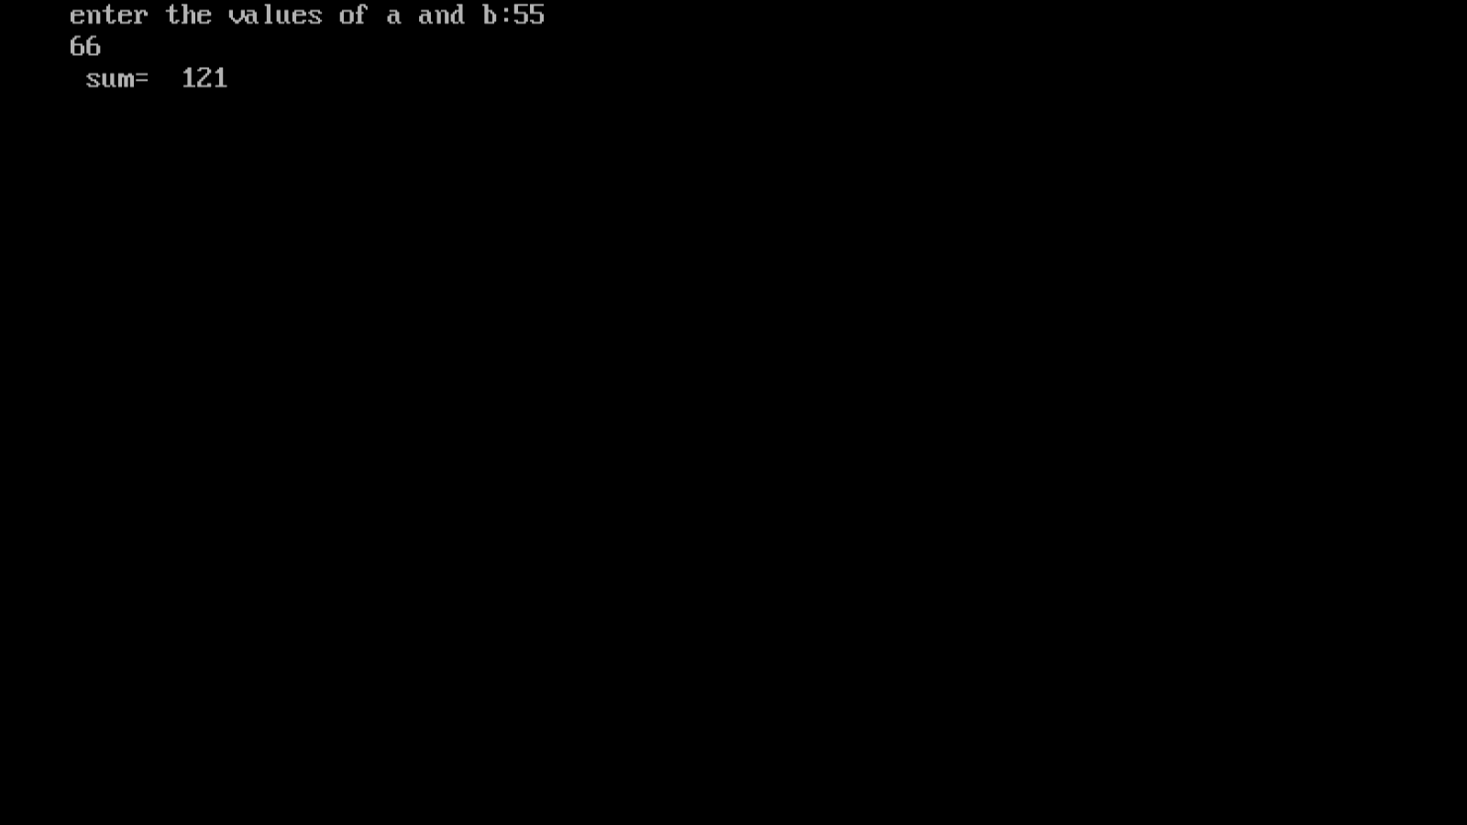

***Program 2:-***  *write a program in C to calculate simple interest for a set of values representing principle number of year and rate of interest.*

***Source code:-***

#include<stdio.h>

#include<conio.h>

void main(){

int p,n ;

float r,si;

clrscr();

printf("enter the principal:");

scanf("%d ",&p);

scanf(“%d”,&n);

printf(“enter annual interest rate:”);

scanf(“%f”,&r);

si=(p*n*r)/100;

printf(" simple interest = %f",si);

getch();}

***Test data:-***

enter the principal:10000

enter the number of years:3

enter annual interest rate:5

simple interest = 1500.000000_

***output screen:-***

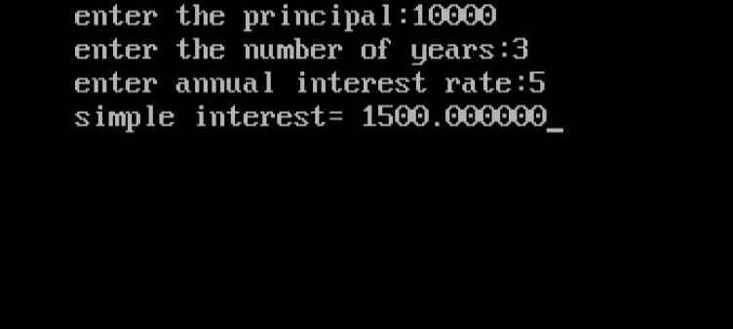

***Program 3:-*** *Ramesh’s basic salary is input through the keyboard his dearness allowance is 40% of basic salary and house rent allowance is 20%. Write a program in c to find his gross salary.*

***Source code:-***

*#include<stdio.h>*

*#include<conio.h>*

*void main(){*

*long int bs,da,hra,gs;*

*clrscr();*

*printf("enter the basic salary of ramesh:");*

*scanf("%ld",&bs);*

*da=(bs*40)/100;*

*hra=(bs*20)/100;*

*gs=bs+da+hra;*

*printf("gross salary: %ld",gs);*

*getch();}*

***test data:-***

enter the basic salary of Ramesh:50000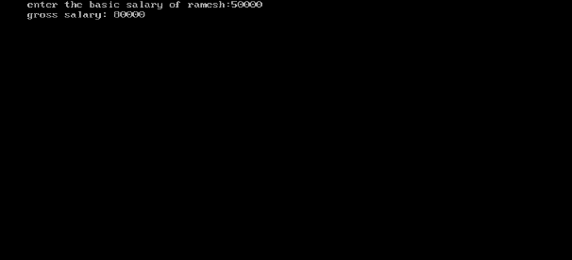

gross salary:80000_

***output screen:-***

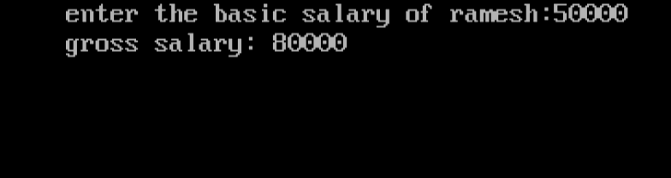

***Program 4:-*** the length and breadth of a rectangle and radius of a circle are input through the keyboard . write a program in C to calculate the area and parameter of the rectangle and the area and circumference of the circle.

***Source code:-***

#include<stdio.h>

#include<conio.h>

# define pi 3.14159

void main(){

int l,b,r,p,ar,ac,c;

clrscr();

printf("enter the length and breadth of rectangle:");

scanf("%d %d",&l,&b);

printf("enter the radius of circle:");

scanf("%d",&r);

p=2*(l+b);

ar=l*b;

ac=pi*r*r;

c=2*pi*r;

printf("parameter of rectangle= %d",p);

printf("area of rectangle= %d",ar);

printf("circumference of circle= %d",c);

printf("area of cicle= %d",ac);

getch();}

***test data:-***

enter the length and breadth of rectangle:20

10

enter the radius of circle:7

parameter of rectangle= 60 area of rectangle=200 circumference of circle=43 area of circle=153

***output screen:-***

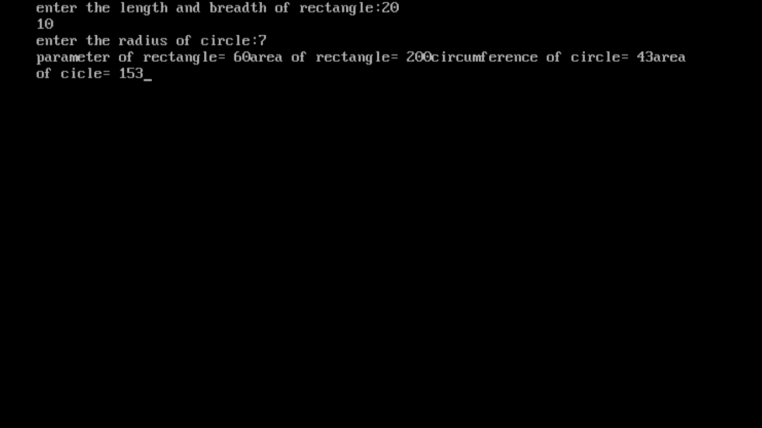

***Program 5:-***  *temperature of the city in Fahrenheit degree is input through keyboard. Write a program in C to convert this temperature in Celsius /centigrade degree.*

***Source code:-***

*#include<stdio.h>*

*#include<conio.h>*

*void main(){*

*float c,f;*

*clrscr();*

*printf("enter the temperature in fahrenheit:");*

*scanf("%f",&f);*

*c=(f-32)*5/9;*

*printf("temperature in celsius= %f",c);*

*getch();}*

***test data:-***

*enter the temperature in Fahrenheit:50*

*temperature in Celsius= 10.000000*

***output screen:-***

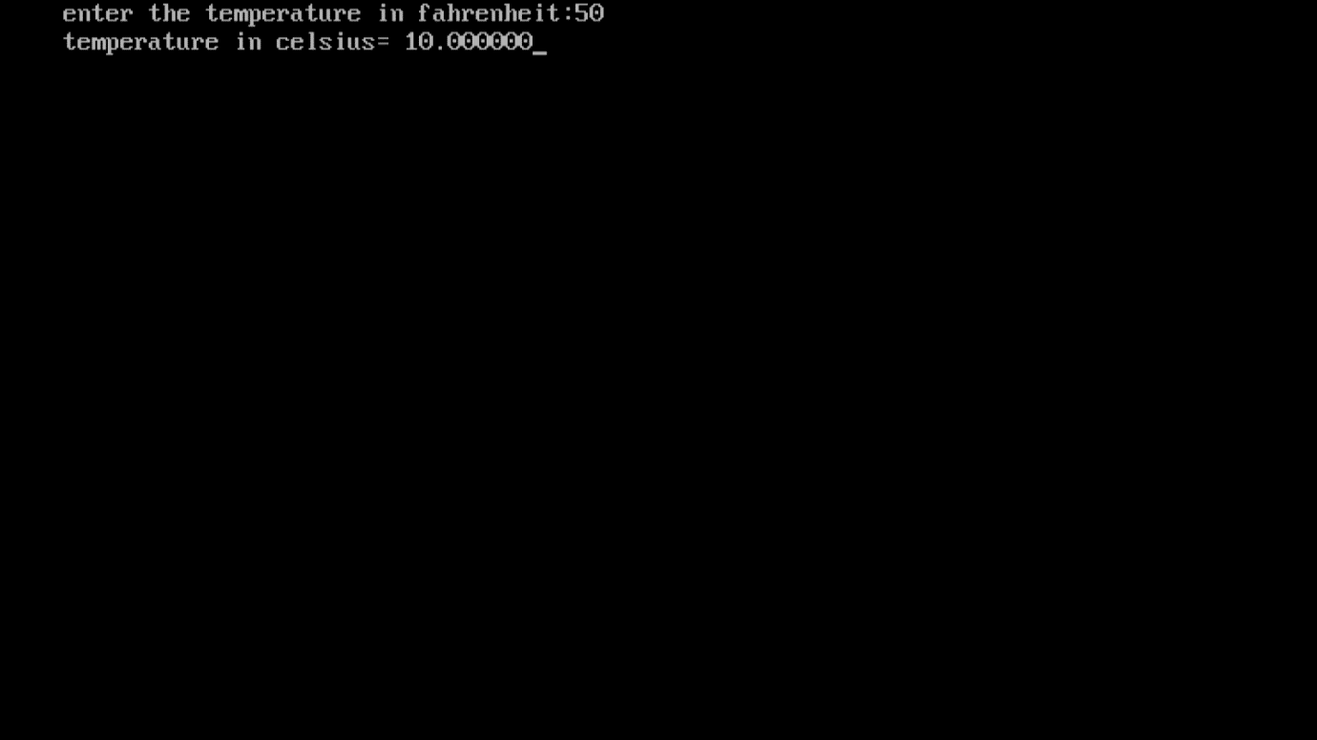

***Program 6:-*** The distance between two cities (in km) input through keyboard . write a program in C to convert the distance into m, feet, inches and cm.

***Source code:-***

#include<stdio.h>

#include<conio.h>

void main(){

float d,m,f,i,cm;

clrscr();

printf("enter the distance in km:");

scanf("%f",&d);

m=1000*d;

i=39370*d;

f=3281*d;

cm=100000*d;

printf("meter= %f",m);

printf("inches= %f",i);

printf("feet= %f",f);

printf("cm= %f",cm);

getch();}

***test data:-***

enter the distance in km:74

meter=74000.000000 inches=2913380.000000 feet = 242794.000000 cm= 7400000.000000_

***output screen:-***

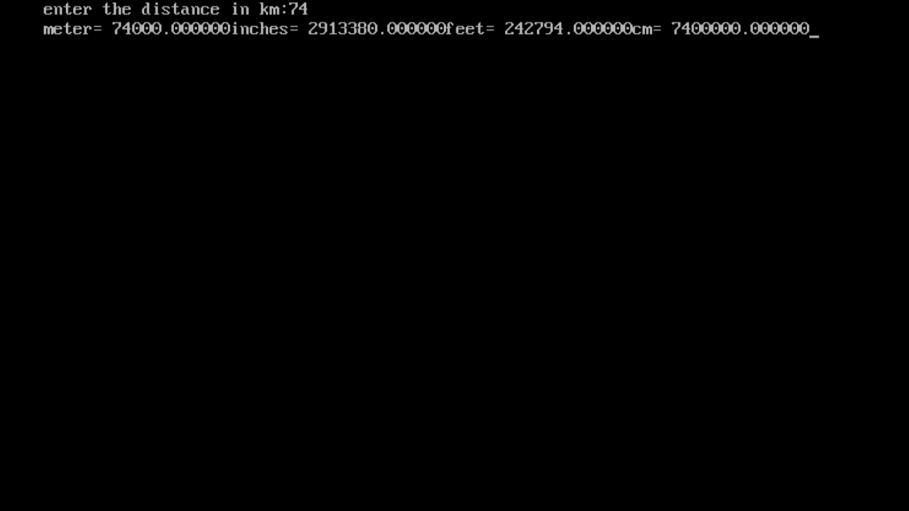

***Program 7:-*** *write a program in C to find the greatest number among 3 numbers given by user.*

***Source code:-***

*#include<stdio.h>*

*#include<conio.h>*

*int main(){*

*int num1,num2,num3;*

*clrscr();*

*printf("enter the number1:");*

*scanf("%d",&num1);*

*printf("enter the number2:");*

*scanf("%d",&num2);*

*printf("enter the number3:");*

*scanf("%d",&num3);*

*if(num1>num2){*

*if(num1>num3){*

*printf("greatest number= %d",num1);}*

*else{*

*printf("greatest number= %d",num3);} }*

*else{*

*printf("greatest number= %d",num2);}*

*return 0;*

*getch();}*

***test data:-***

*enter the number1:60*

*enter the number2:50*

*enter the number3:30*

*greatest number=60*

***output screen:-***

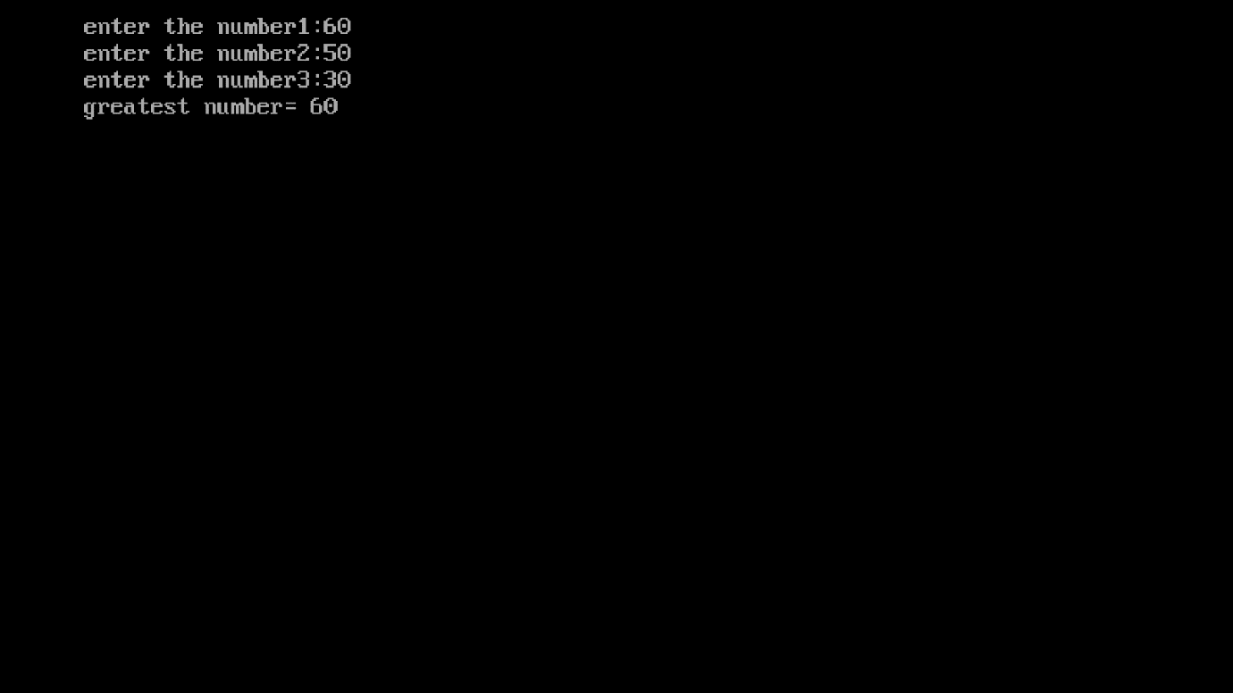

***Program 8:-*** *while purchasing a certain item a discount of 10% is offered if the quantity purchased more than 1000 if quantity and price input through keyboard . write a program in C to calculate total expenses.*

***Source code:-***

*#include<stdio.h>*

*#include<conio.h>*

*void main(){*

*int price,a,tp;*

*clrscr();*

*printf("enter the total price:");*

*scanf("%d",&price);*

*if(price>1000){*

*a=(price*10)/100;*

*tp=price-a;*

*printf("total price is %d",tp); }*

*else{*

*printf("total price is %d",price); }*

*getch(); }*

***test data:-***

*enter the total price : 1500*

*total price is 1350*

***output screen:-***

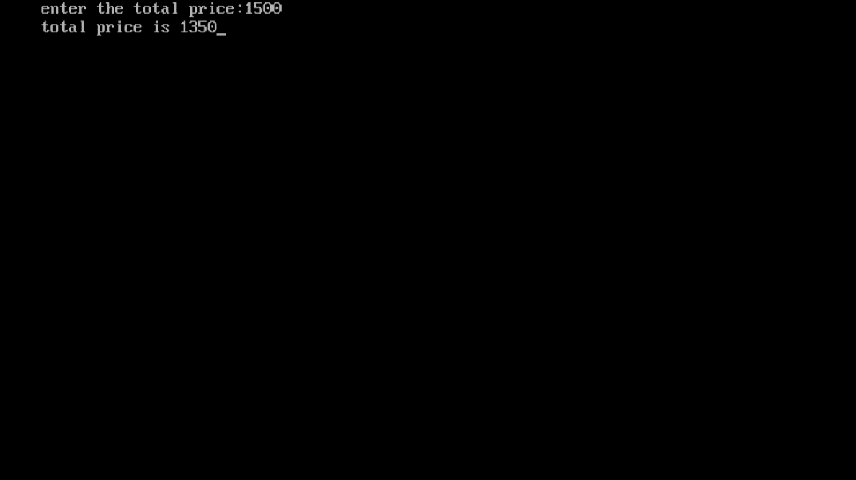

***Program 9:-****Two numbers are input through the keyboard into contents two location C and D . write a program to interchange the of C and D without using third variables.*

***Source code:-***

*#include<stdio.h>*

*#include<conio.h>*

*void main(){*

*int c,d;*

*clrscr();*

*printf("enter the values of c and d:");*

*scanf("%d %d",&c,&d);*

*printf(" values before exchange c,d= %d %d",c,d);*

*c=c+d;*

*d=c-d;*

*c=c-d;*

*printf("values after exchange c,d= %d %d",c,d);*

*getch(); }*

***test data:-***

*enter the values of c and d:50*

*60*

*Values before exchange c,d=50 60 values after exchange c,d=60 50*

***Output screen:-***

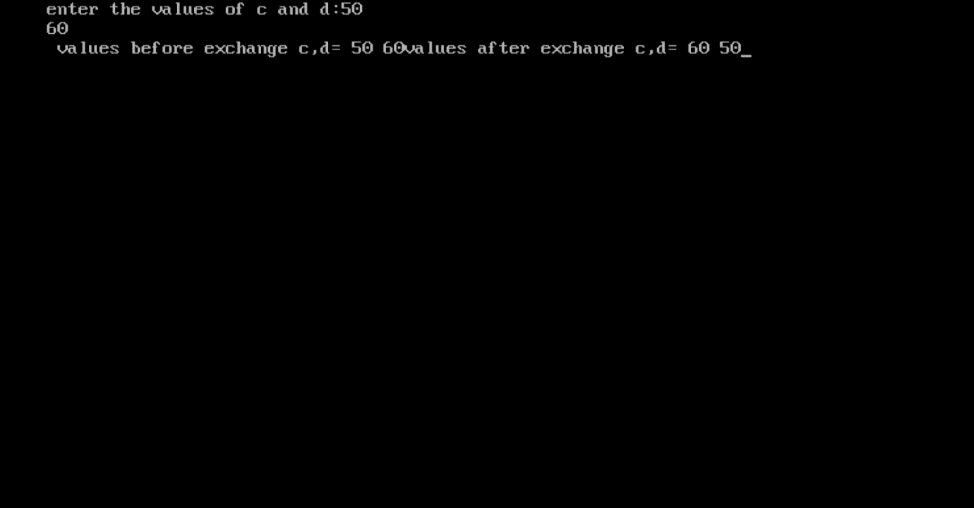

***Program 10:-*** *Two numbers are input through the keyboard into two location C and D . write a program to interchange the contents of C and D with using third variables.*

***Source code:-***

*#include<stdio.h>*

*#include<conio.h>*

*void main(){*

*int c,d,x;*

*clrscr();*

*printf("enter the values of c and d:");*

*scanf("%d %d",&c,&d);*

*printf(" values before exchange c,d= %d %d",c,d);*

*x=c;*

*c=d;*

*d=x;*

*printf("values after exchange c,d= %d %d",c,d);*

*getch(); }*

***test data:-***

*enter the values of c and d:70*

*80*

*Values before exchange c,d=70 80 values after exchange c,d=80 70*

***Output screen:-***

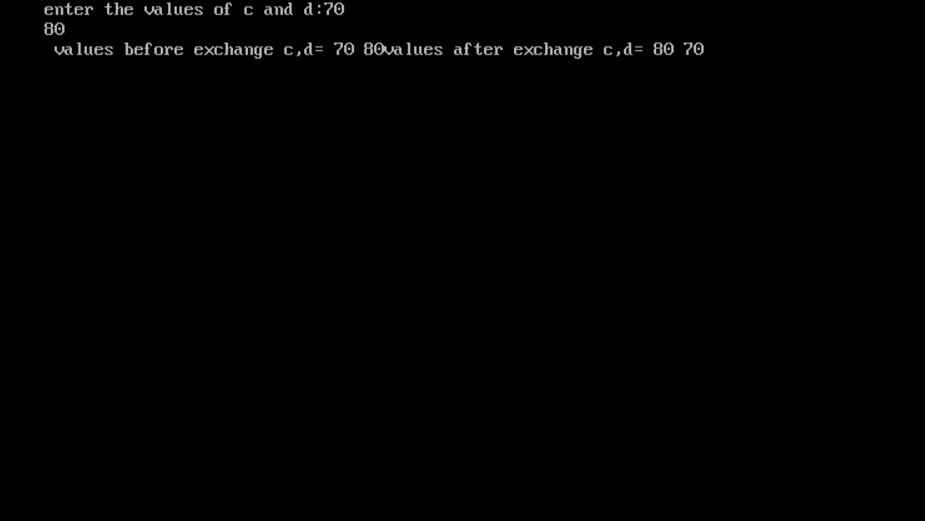

***Program 11:-***  *If a five digit number is input through the keyboard. Write a program in C to calculate the sum of its digit.*

***Source code:-***

*#include<stdio.h>*

*#include<conio.h>*

*void main(){*

*int num,x,ld,total=0;*

*printf("enter the five digit number:");*

*scanf("%i",&num);*

*ld=num%10;*

*total=ld;*

*x=(num/10)%10;*

*total=total+x;*

*x=(num/100)%10;*

*total=total+x;*

*x=(num/1000)%10;*

*total=total+x;*

*x=(num/10000)%10;*

*total=total+x;*

*printf("sum= %d",total);*

*getch(); }*

***test data:-***

*enter the five digit number:23456*

*sum=20*

***output screen:-*** 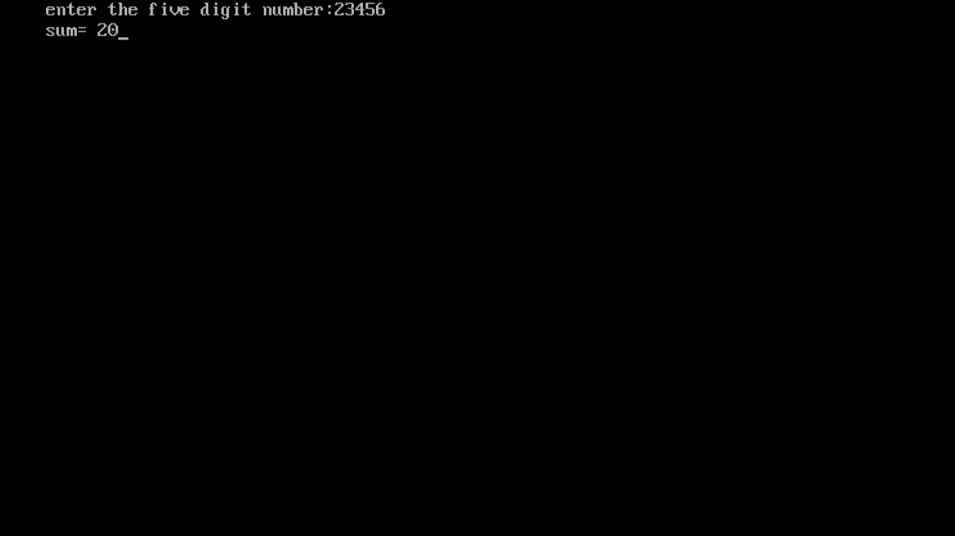

***program 12:-*** *If a five digit number is input through the keyboard write a program in C to reverse a number.*

***Source code:-***

*#include<stdio.h>*

*#include<conio.h>*

*void main(){*

*long int n,x1,x2,x3,x4,rev;*

*clrscr();*

*printf("enter a five digit number:");*

*scanf("%ld",&n);*

*x1=n%10;*

*n=n/10;*

*x2=n%10;*

*n=n/10;*

*x3=n%10;*

*n=n/10;*

*x4=n%10;*

*n=n/10;*

*rev=x1*10000+x2*1000+x3*100+x4*10+n;*

*printf("the reversed number is= %ld",rev);*

*getch();}*

***test data:-***

*enter a five digit number:23456*

*the reversed number is=65432*

***output screen:-*** 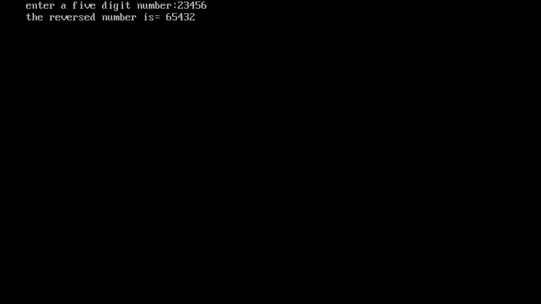

***program 13:-*** *IF an employee basic salary is less than 1500 then his hra will be 10% of the basic salary and da will be 90% of the basic salary .If his salary either equal to or above 1500 then hra will be Rs500 and da will be 98% of the basic salary .if the employee salary input through the keyboard. Write a program in C to find gross salary.*

***Source code:-***

*#include<stdio.h>*

*#include<conio.h>*

*void main(){*

*float bs,hra,da,gs;*

*printf("enter the basic salary=");*

*scanf("%f",&bs);*

*if(bs<1500){*

*hra=(bs*10)/100;*

*da=(bs*90)/100;*

*gs=bs+hra+da;*

*printf("gross salary= %f",gs);}*

*else{*

*hra=500;*

*da=(bs*98)/100;*

*gs=bs+hra+da;*

*printf("gross salary= %f",gs); }*

*getch(); }*

***test data:-***

*enter the basic salary=1600*

*gross salary= 3668.000000 enter the basic salary=800*

*gross salary=1600.000000*

***output screen:-***

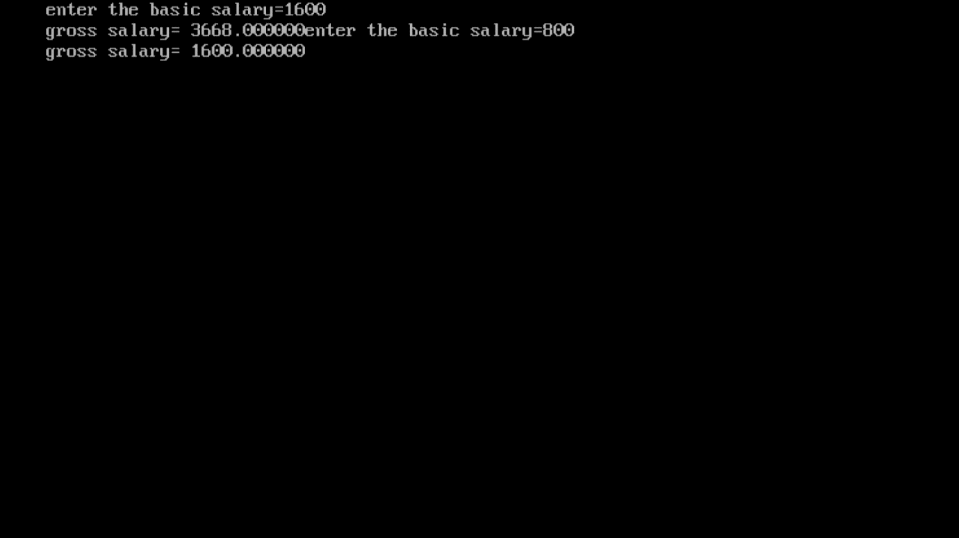

***Program14:- write a program to check if a given number is odd or even.***

***Source code:-***

*#include<stdio.h>*

*#include<conio.h>*

*void main(){*

*int num;*

*clrscr();*

*printf("enter a number:");*

*scanf("%i",&num);*

*if(num%2==0){*

*printf("number is even %i",num);*

*}*

*else{*

*printf("number is odd %i",num);*

*}*

*getch();}*

***test data:-***

*enter a nuber:33*

*number is odd 33*

***output screen:-***

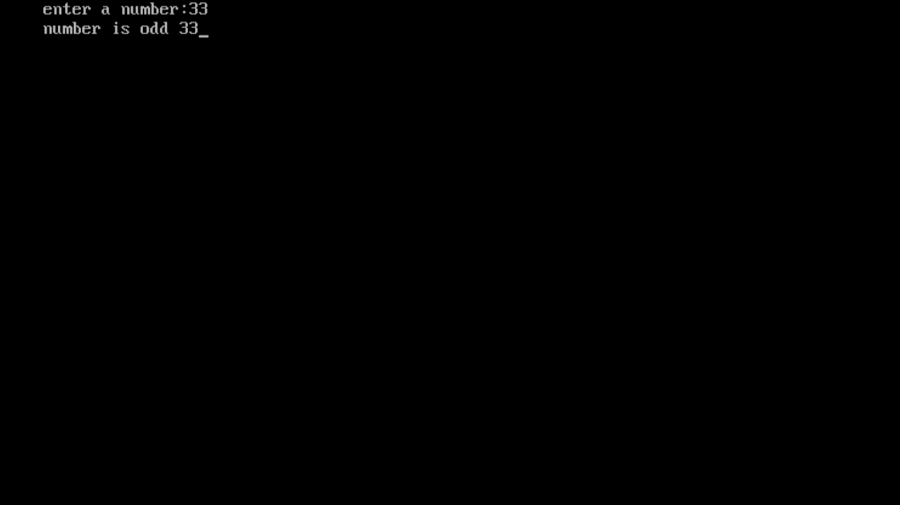

***Program15:- Write a program to check if a given number is prime or not.***

***Source code:-***

***#include<stdio.h>***

***#include<conio.h>***

***void main(){***

***int num,i;***

***clrscr();***

***printf("enter a number : ");***

***scanf("%d",&num);***

***i=2;***

***while(i<num==1){***

***if(num%i==0){***

***printf("not a prime ");***

***break; }***

***i++; }***

***if (i==num){***

***printf(" prime number.");***

***}***

***getch(); }***

***test data:-***

*enter a number:13*

*prime number.*

***Output screen:-***

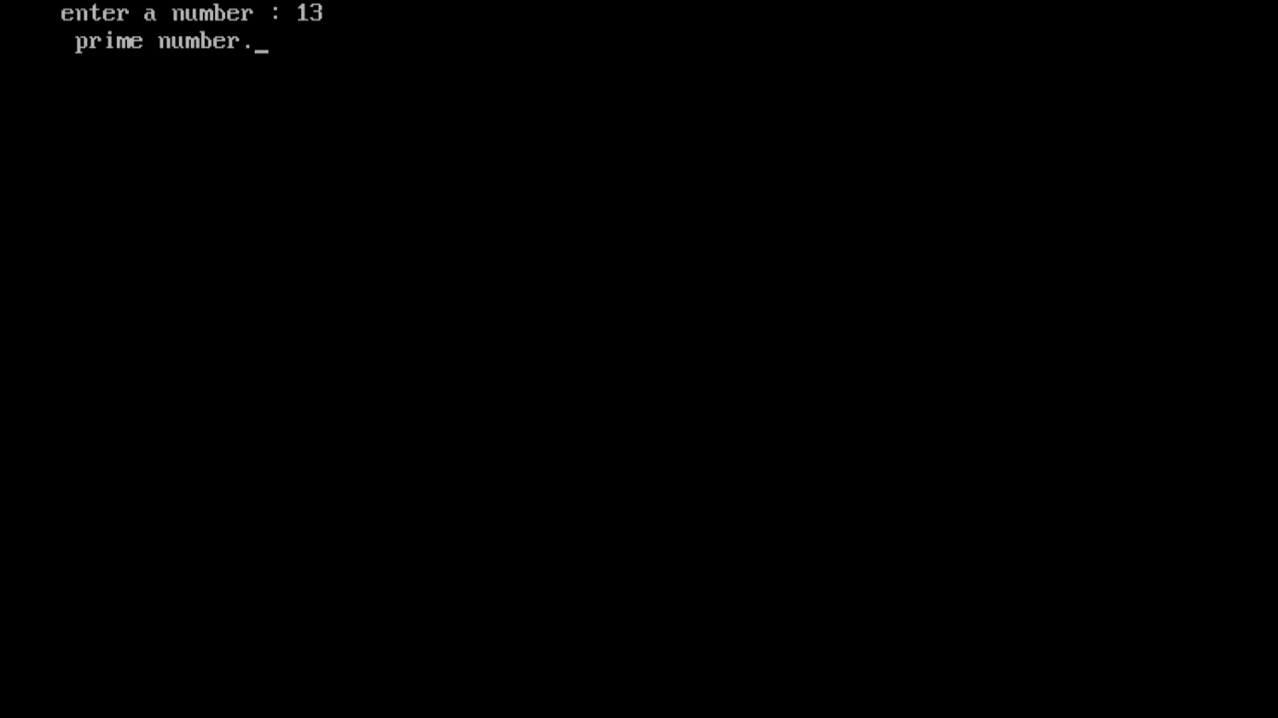

***Program 16:- Write a program to check whether the given number is even or odd using conditional operator.***

***Source code:-***

*#include<stdio.h>*

*#include<conio.h>*

*void main(){*

*int num;*

*clrscr();*

*printf("enter a number: ");*

*scanf("%d",&num);*

*(num%2==0)?printf("number is even"):printf("number is odd");*

*getch();}*

***test data:-***

*enter a number:12*

*number is even*

***output screen:-***

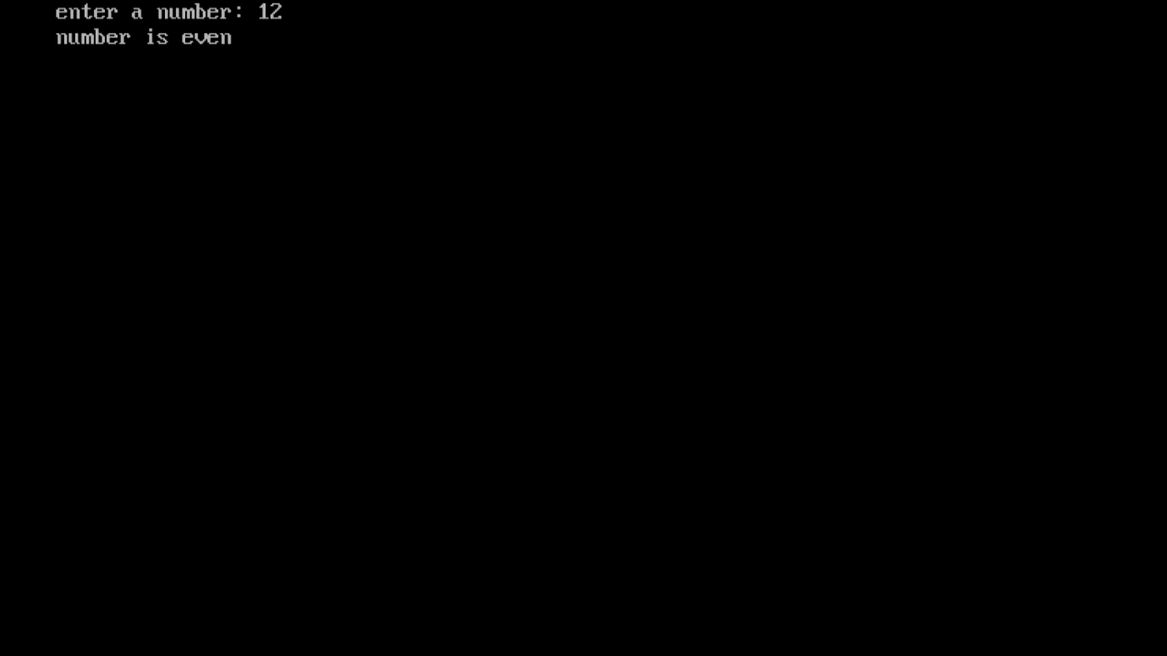

***Program17:- write a program to find the average of 6 subjects and display the result as follows.***

***Source code:-***

*#include<stdio.h>*

*#include<conio.h>*

*void main(){*

*int a,b,c,d,e,f;*

*float avg;*

*clrscr();*

*printf("enter the marks:");*

*scanf("%d",&a);*

*printf("enter the marks:");*

*scanf("%d",&b);*

*printf("enter the marks:");*

*scanf("%d",&c);*

*printf("enter the marks:");*

*scanf("%d",&d);*

*printf("enter the marks:");*

*scanf("%d",&e);*

*printf("enter the marks:");*

*scanf("%d",&f);*

*avg=(a+b+c+d+e+f)/6;*

*if(a<35 || b<35 || c<35 || d<35 || e<35 || f<35){*

*printf("fail"); }*

*else{*

*if (avg>=35 && avg<50){*

*printf("third division"); }*

*if(avg>=50 && avg<60){*

*printf("second division");}*

*if(avg>=60 && avg<75){*

*printf("first division");}*

*if (avg>=75 && avg<=100){*

*printf("distinction"); }*

*}*

*getch();*

*}*

***Test data:-***

*Enter the marks:25*

*Enter the marks:30*

*Enter the marks:55*

*Enter the marks:66*

*Enter the marks:70*

*Enter the marks:56*

*Fail*

***Output screen:-***

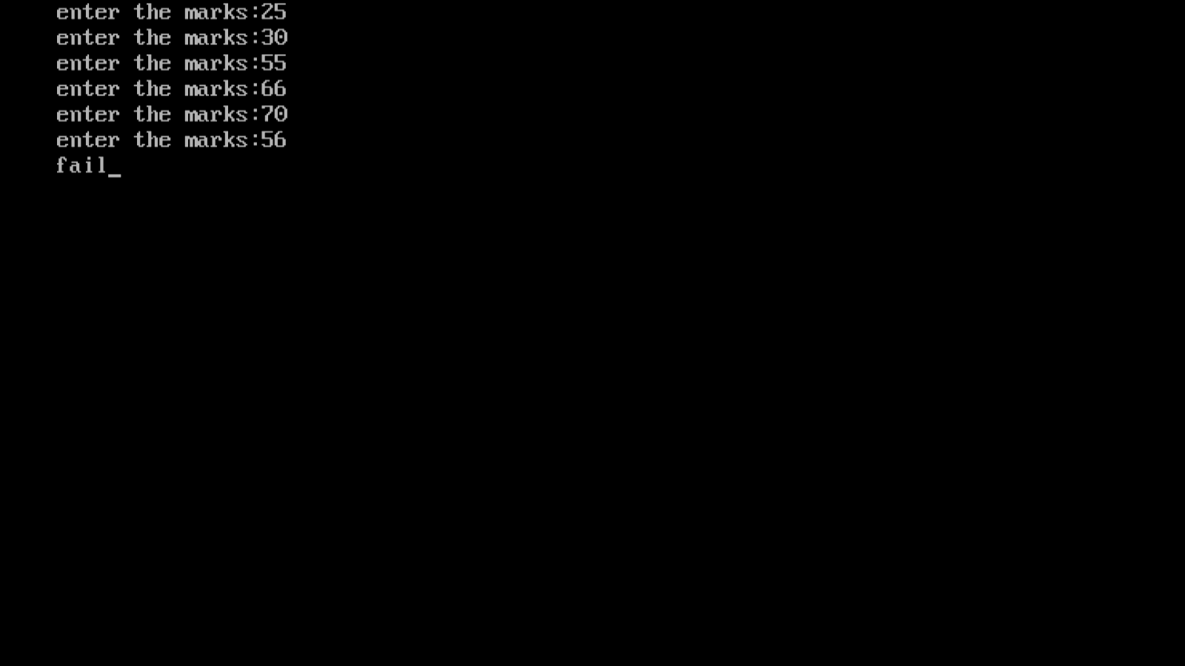

***Program 18:-*** ***write a program in C to print a table of any number using for loop.***

***Source code:-***

*#include<stdio.h>*

*#include<conio.h>*

*void main(){*

*int num,i;*

*clrscr();*

*printf("enter the number:");*

*scanf("%d",&num);*

*printf("table of %d \n",num) ;*

*for (i=1;i<=10;i++){*

*printf("%d x %d = %d \n",num,i,num*i); }*

*getch(); }*

***test data:-***

*enter a number:7*

*table of 7*

*7 x 1 = 7*

*7 x 2 = 14*

*7 x 3 = 21*

*7 x 4 = 28*

*7 x 5 = 35*

*7 x 6 = 42*

*7 x 7 = 49*

*7 x 8 = 56*

*7 x 9 = 63*

*7 x 10 = 70*

***Output screen:-***

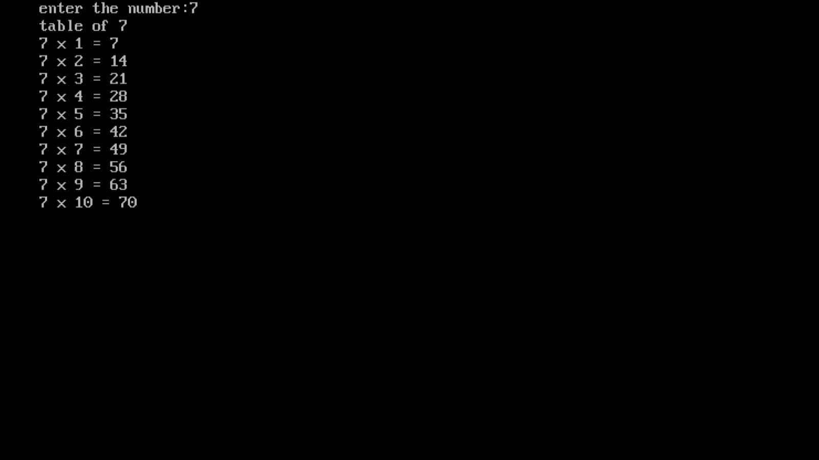

***Program 19:-*** ***write program in C to print table of any number using while loop.***

***Source code:-***

*#include<stdio.h>*

*#include<conio.h>*

*void main(){*

*int num,i=1;*

*clrscr();*

*printf("enter the number:");*

*scanf("%d",&num);*

*printf("table of %d \n",num) ;*

*while(i<=10){*

*printf("%d x %d = %d \n",num,i,num*i);*

*i++; }*

*getch(); }*

***test data:-***

*enter a number:5*

*table of 5*

*5 x 1 = 5*

*5 x 2 = 10*

*5 x 3 = 15*

*5 x 4 = 20*

*5 x 5 = 25*

*5 x 6 = 30*

*5 x 7 = 35*

*5 x 8 = 40*

*5 x 9 = 45*

*5 x 10 = 50*

***Output screen:-***

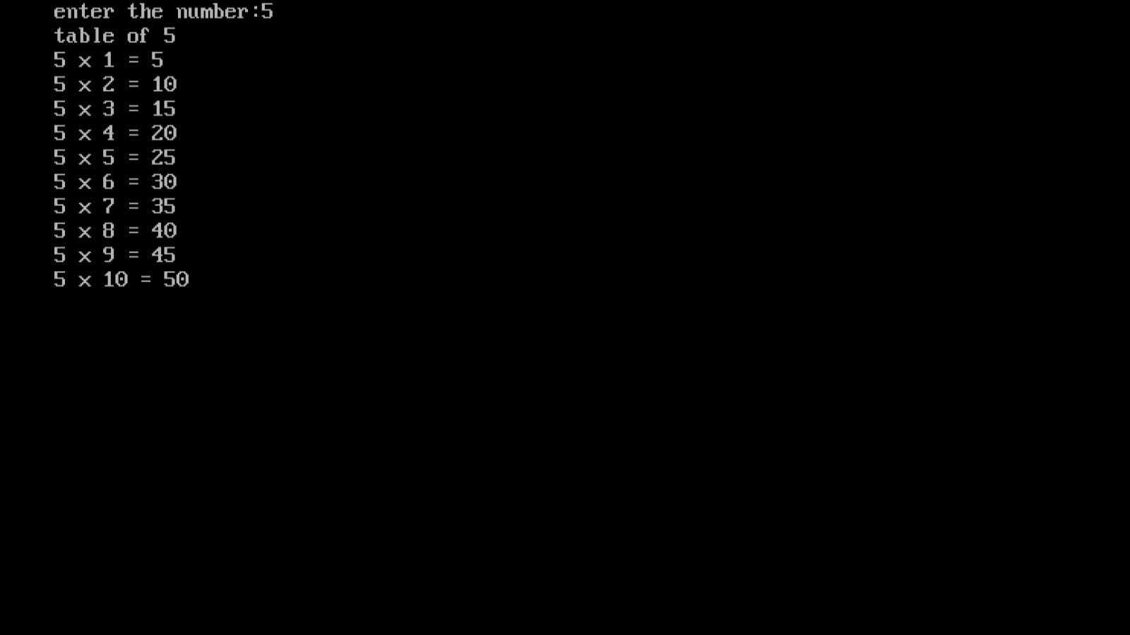

***Program20:-*** ***write a program to find the factorial value of any number entered through the keyboard.***

***Source code:-***

*#include<stdio.h>*

*#include<conio.h>*

*void main(){*

*int num,f=1,n;*

*clrscr();*

*printf("enter a number:");*

*scanf("%d",&num);*

*n=num;*

*while(num!=0){*

*f=f*num;*

*num=num-1; }*

*printf("the factorial for %d is %d",n,f);*

*getch(); }*

***test data :-***

*enter a number:6*

*the factorial for 6 is 720.*

***Output screen:-***

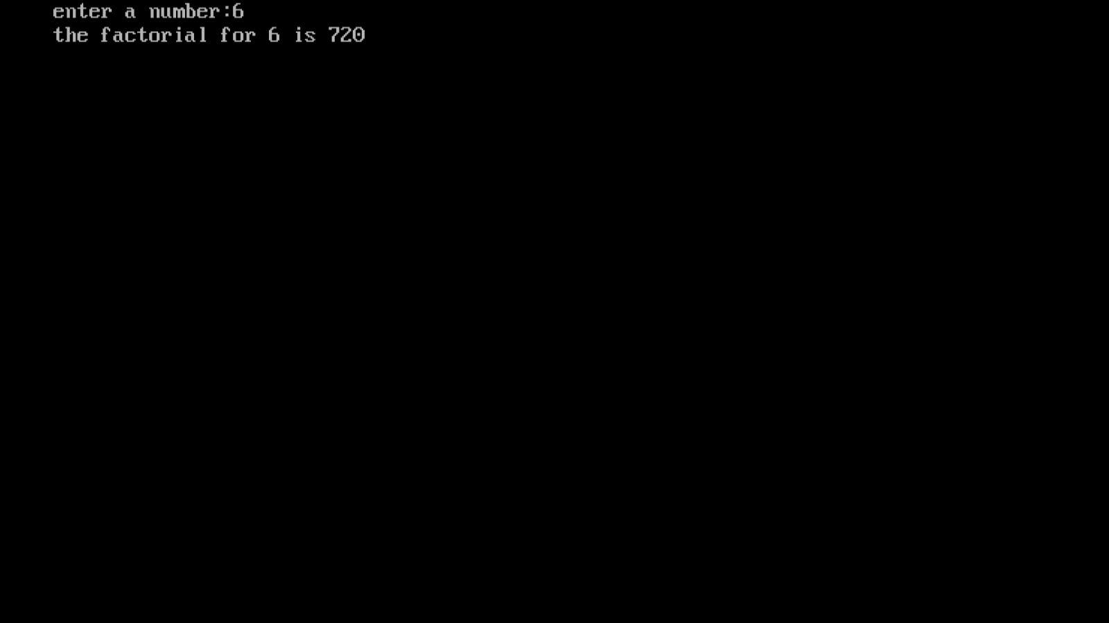

***Program 21:-*** ***write a program to calculate the salary of three persons the given data basic salary is input through keyboard***

***Hra = bs of 90%***

***Da = 10% of bs***

***Calculate gross salary***

***Source code:-***

*#include<stdio.h>*

*#include<conio.h>*

*void main(){*

*float bs,hra,da,gs;*

*int i;*

*clrscr();*

*for(i=1;i<=3;i++) {*

*printf("enter the basic salary=");*

*scanf("%f",&bs);*

*hra=(bs*90)/100;*

*da=(bs*10)/100;*

*gs=bs+hra+da;*

*printf("gross salary= %f \n",gs); }*

*getch(); }*

***test data:-***

*enter the salary=45000*

*gross salary=90000.000000*

*enter the salary=35000*

*gross salary=70000.000000*

*enter the salary=16000*

*gross salary=32000.000000*

***output screen:-***

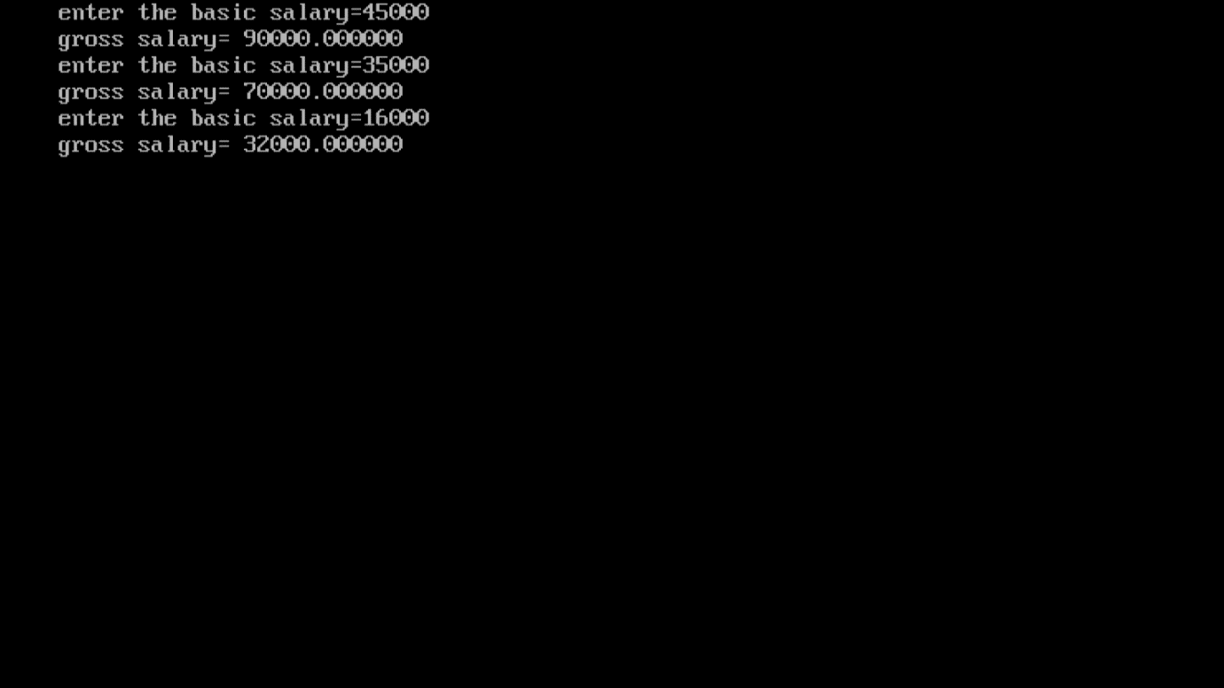

***Program22:-*** ***Write a program to print all Armstrong number between 1 and 500.***

***Source code:-***

*#include<stdio.h>*

*int main(){*

*int num,r,sum,t=1;*

*for(t=1;t<=500;t++){*

*num=t;*

*sum=0;*

*while(num){*

*r=num%10;*

*sum=sum+(r*r*r);*

*num=num/10;}*

*if(t==sum) {*

*printf("%d is a armstrong number\n",t);}*

*t++; }*

*return 0; }*

***test data:-***

*1 is a Armstrong number.*

*153 is a Armstrong number.*

*371 is a Armstrong number.*

*407 is a Armstrong number.*

***Output screen:-***

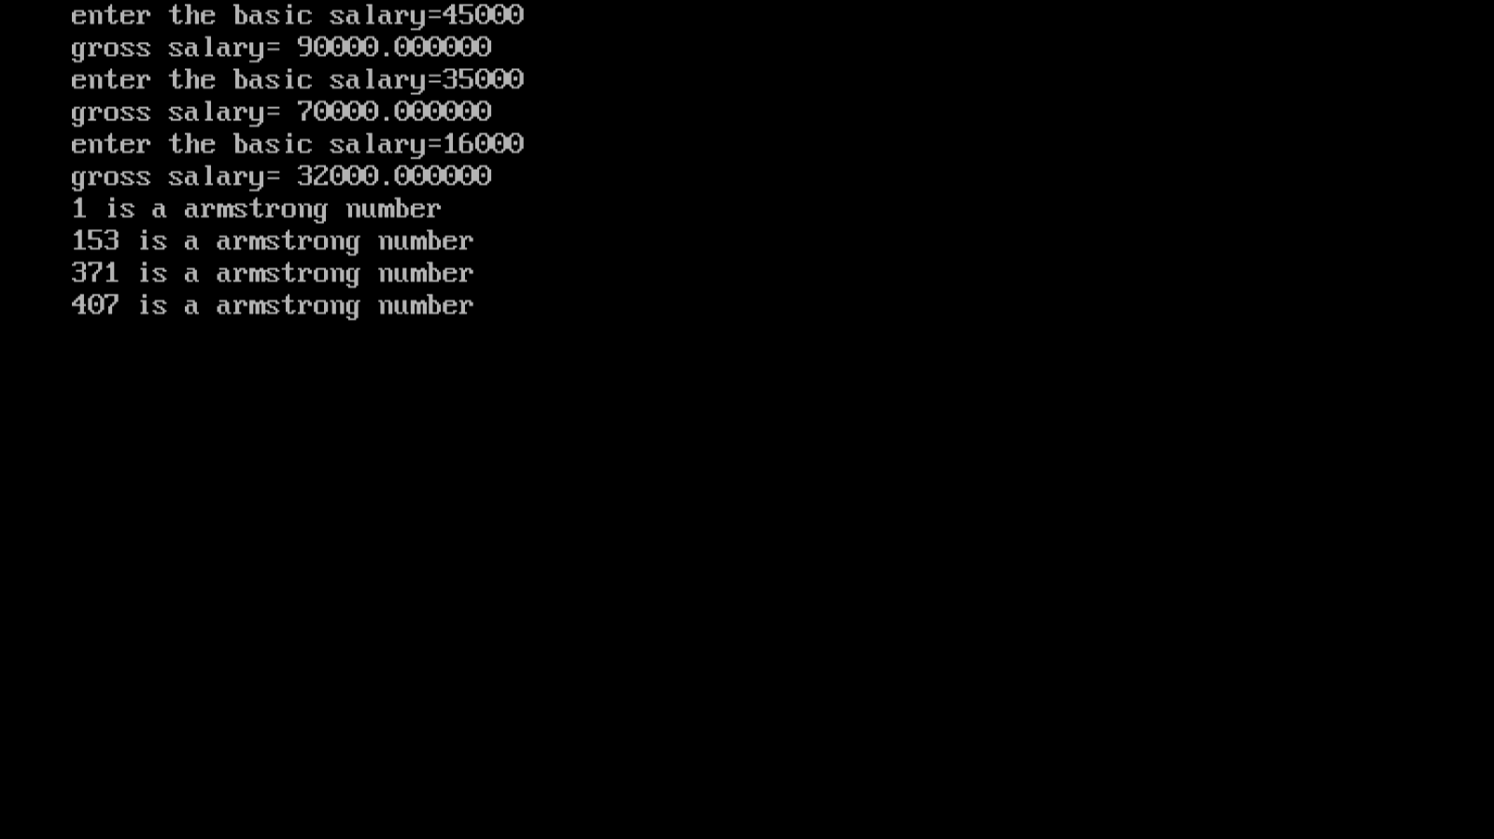

***Program 23:- two numbers are entered through keyboard write a program to find value of 1 raised to the power of another.***

***Source code:-***

#include<stdio.h>

#include<conio.h>

void main(){

int num1,i,num2,m=1;

printf("enter two numbers:");

scanf("%d %d",&num1,&num2);

for(i=1;i<=num2;i++){

m=m*num1;}

printf("%d raised to %d is: %d",num1,num2,m);

getch();

}

***Test data:-***

*enter two numbers:2*

*4*

*2 raised to 4 is: 16*

***Output screen:-***

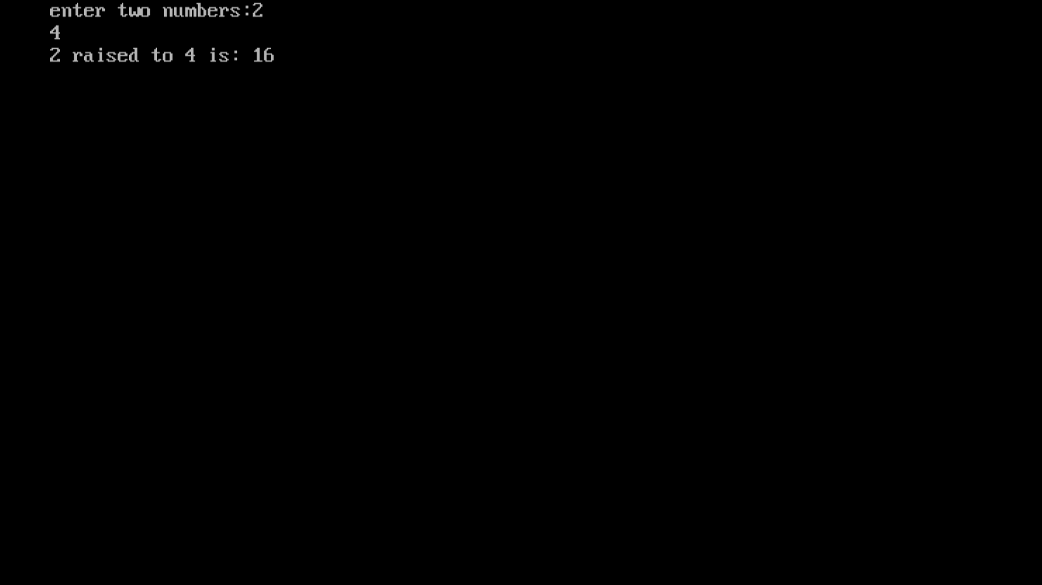

***Program24:-*** ***write a program to find if the number is factorial ,Prime or not, odd or even and exit using switch case.***

***Source code:-***

*#include<stdio.h>*

*#include<conio.h>*

*void main(){*

*int choice,i,c=1,no;*

*printf("enter a choice:\n 1.factorial\n 2.prime\n 3.even/odd\n:");*

*scanf("%d",&choice);*

*switch(choice){*

*case 1:*

*printf("enter a no:");*

*scanf("%d",&no);*

*for(i=1;i<no;i++){*

*c=c*i;*

*if(c==no){printf("%d",i);*

*break;}*

*else{continue;}}*

*if(c==no){printf(" factorial is %d",no);}*

*else{printf("enter a proper number");}*

*break;*

*case 2:*

*printf("enter a number : ");*

*scanf("%d",&no);*

*i=2;*

*while(i<no==1){*

*if(no%i==0){*

*printf("not a prime ");*

*break; }*

*i++; }*

*if (i==no){*

*printf(" prime number.");*

*}*

*break;*

*case 3:*

*printf("enter a number: ");*

*scanf("%d",&no);*

*(no%2==0)?printf("number is even"):printf("number is odd");*

*break;*

*}*

*getch();}*

***Test data:-***

*Enter a choice:*

*1.factorial*

*2.prime*

*3.even/odd*

*:1*

*Enter a no:720*

*6 factorial is720 Enter a choice:*

*1.factorial*

*2.prime*

*3.even/odd*

*:2*

*Enter a number : 33*

*Not a prime number Enter a choice:*

*1.factorial*

*2.prime*

*3.even/odd*

*:3*

*Enter a number: 2*

*Number is even*

***Output screen:-*** 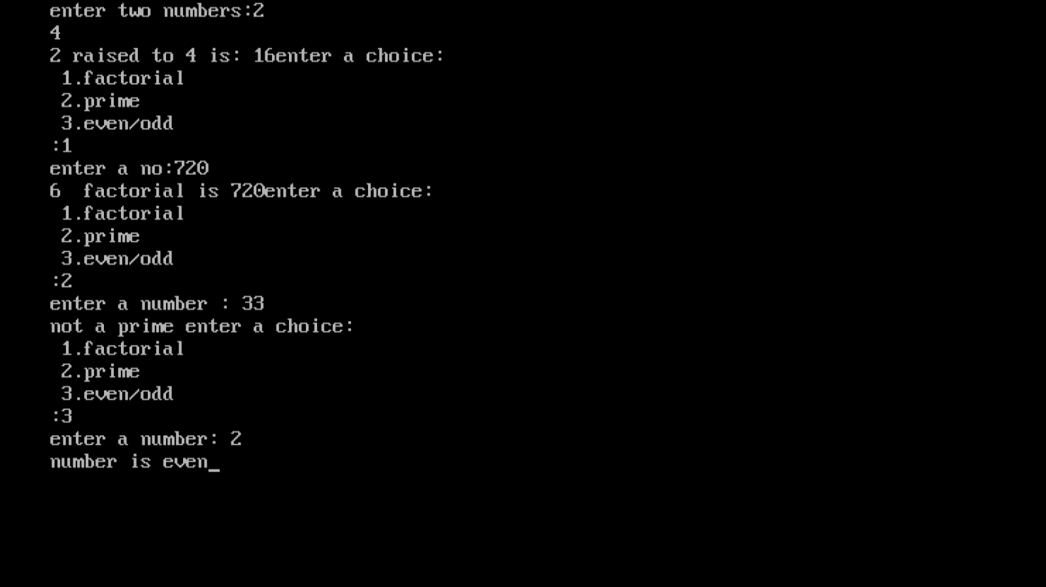

***Program25:-Write a menu driven program to construct a calculator for the following arithmetic operations: addition, subtraction, multiplication, division, average and percentage.***

***Source code:-*** ***#include<stdio.h>***

#include<conio.h>

void main(){

int choice,m,sum=0,sub=0,n,no,i,avg,div;

long float b,p;

clrscr();

printf("enter a choice:\n 1.addition\n 2.subtraction\n 3.multiplication\n 4.division\n 5.average\n 6.percentage\n =>");

scanf("%d",&choice);

switch(choice){

case 1:

printf("enter how many numbers you want to add :");

scanf("%d",&n);

for(i=1;i<=n;i++){

printf("enter a no:");

scanf("%d",&no);

sum=sum+no;}

printf("addition of numbers=%d",sum);

break;

case 2:

printf("enter two no:");

scanf("%d %d",&n,&no);

sub=n-no;

printf("subtraction = %d",sub);

break;

case 3:

printf("enter two no:");

scanf("%d %d",&n,&no);

m=n*no;

printf("%d X %d = %d",n,no,m);

break;

case 4:

printf("enter two no:");

scanf("%d %d",&n,&no);

div=n/no;

printf("%d divide by %d=%d",n,no,div);

break;

case 5:

printf("enter how many numbers average you want to find\n");

scanf("%d",&n);

for(i=1;i<=n;i++){

printf("enter a no:");

scanf("%d",&no);

sum=sum+no;}

avg=sum/n;

printf("average=%d",avg);

break;

case 6:

printf("enter a percentage:");

scanf("%d",&n);

printf("enter a total no:");

scanf("%lf",&b);

p=(b*n)/100;

printf("percentage=%lf",p);

break;

}

getch();

}

***Test data:-***

enter a choice:

1.addition

2.subtraction

3.multiplication

4.division

5.average

6.percentage

=>6

Enter a percentage:10

Enter a total no: 40000

Percentage=4000.000000

***Output screen:-*** 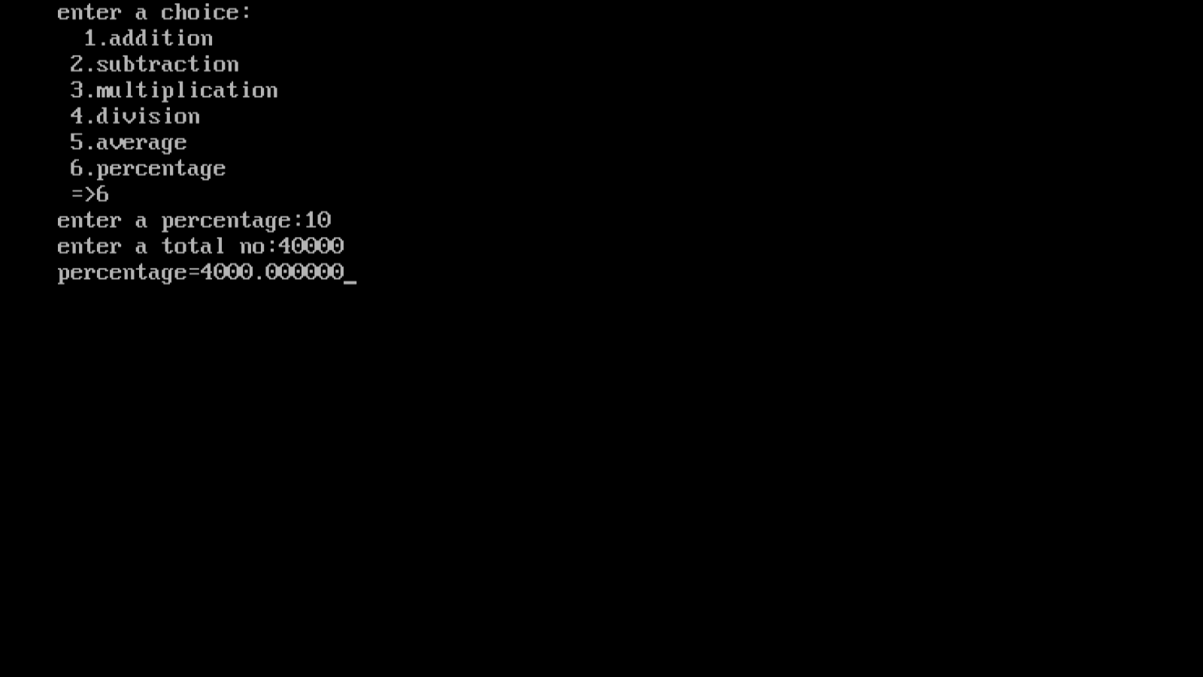

***Program26:- Write a menu driven program for the following operations:(1) Print Armstrong number up to N.***

***(2)Display prime numbers between 1 to N.***

***(3) reverse of an integer.***

***Source code:-*** #include<stdio.h>

#include<conio.h>

void main(){

int ch,n,t=1,num,r,i,j,sum;

long int x1,x2,x3,x4,rev;

clrscr();

printf("enter a choice:\n 1.print armstrong numbers upto N\n 2.display prime numbers between 1 to N\n 3.reverse of an integer\n =>");

scanf("%d",&ch);

switch(ch){

case 1:

printf("enter the value of N:");

scanf("%d",&n);

for(t=1;t<=n;t++){

num=t;

sum=0;

while(num){

r=num%10;

sum=sum+(r*r*r);

num=num/10;

}

if(t==sum) {

printf("%d is a armstrong number\n",t);}

t++;

}

break;

case 2:

printf("enter the value of N:");

scanf("%d",&n);

printf("prime no are:-\n");

for(i=2;i<=n;i++){

int c=0;

for(j=1;j<=i;j++){

if(i%j==0){c++;}

}

if(c==2){printf("%d\n",i);}

}

break;

case 3:

printf("enter a five digit number:");

scanf("%ld",&n);

x1=n%10;

n=n/10;

x2=n%10;

n=n/10;

x3=n%10;

n=n/10;

x4=n%10;

n=n/10;

rev=x1*10000+x2*1000+x3*100+x4*10+n;

printf("the reversed number is= %ld",rev);

break;

}

}

***Output screen:-***

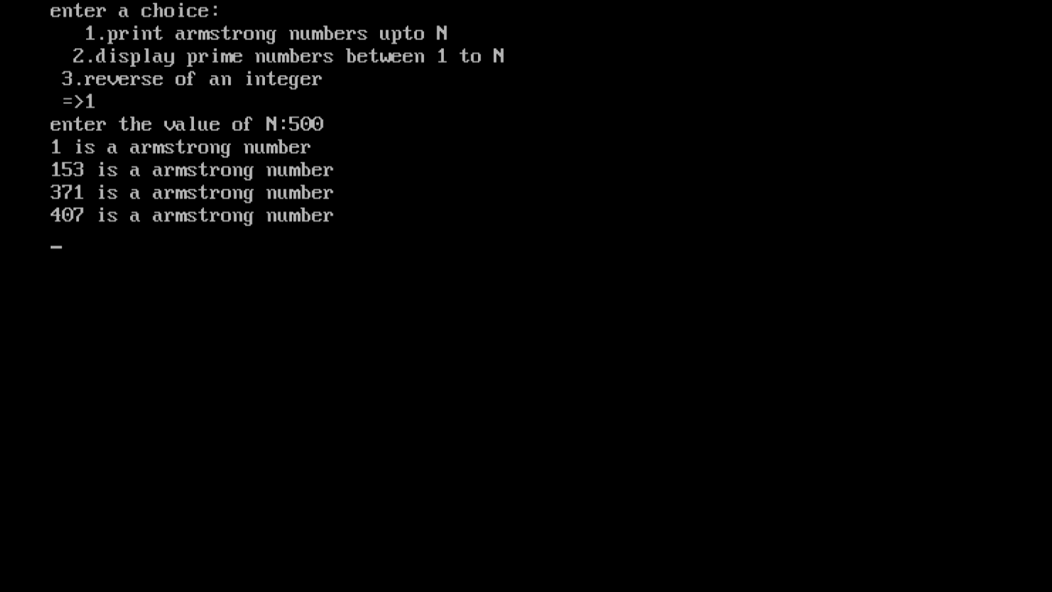

***Program 27:- write a program to print the odd and even numbers from 1 to 100***

***Source code:-***

*#include<stdio.h>*

*#include<conio.h>*

*void main(){*

*int i,j;*

*clrscr();*

*printf("even numbers:-\n");*

*for(i=2;i<=100;i=i+2){printf("%d,",i);}*

*printf("\nodd numbers:-\n");*

*for(i=1;i<100;i=i+2){printf("%d,",i);}*

*getch();*

*}*

***Output:-***

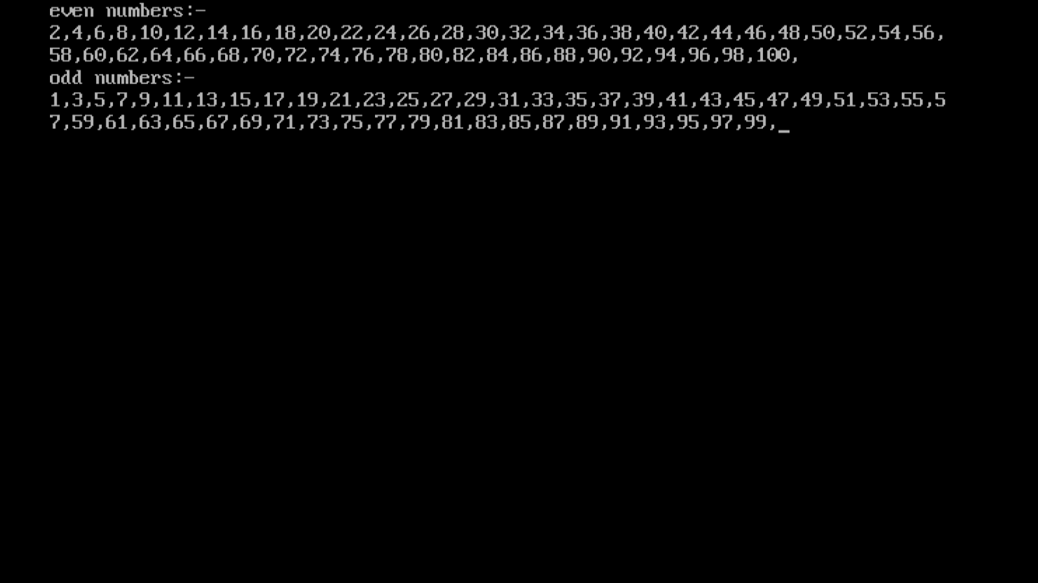

***Program.28:- Write a program in C to swap two numbers using call by value.***

***Source code:-***

*#include<stdio.h>*

*#include<conio.h>*

*void swap(int,int);*

*void main(){*

*int a,b;*

*clrscr();*

*printf("enter two numbers:");*

*printf("\na=");*

*scanf("%d",&a);*

*printf("b=");*

*scanf("%d",&b);*

*printf("before swapping:a=%d,b=%d\n",a,b);*

*swap(a,b);*

*getch();*

*}*

*void swap(int a,int b){*

*int temp;*

*temp=a;*

*a=b;*

*b=temp;*

*printf("after swapping\n");*

*printf("a=%d\n",a);*

*printf("b=%d\n",b);*

*}*

***Output:-***

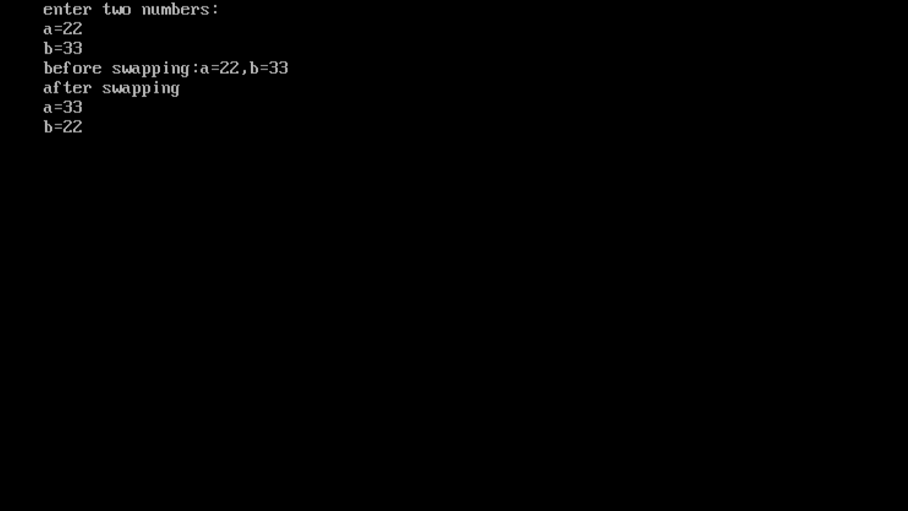

***Program 29:- Write a program in C to swap two numbers using call by refrence.***

***Source code:-***

*#include<stdio.h>*

*#include<conio.h>*

*void swap(int*,int*);*

*void main(){*

*int a,b;*

*clrscr();*

*printf("enter 2 numbers:\n a=");*

*scanf("%d",&a);*

*printf("b=");*

*scanf("%d",&b);*

*printf("\nbefore swapping:\na=%d,b=%d");*

*printf("\nafter swapping\n");*

*swap(&a,&b);*

*getch();}*

*void swap(int *a,int *b){*

*int temp;*

*temp=*a;*

*\*a=*b;*

*\*a=temp;*

*printf("a=%d,",*a);*

*printf("b=%d",*b);*

*}*

***Output:-***

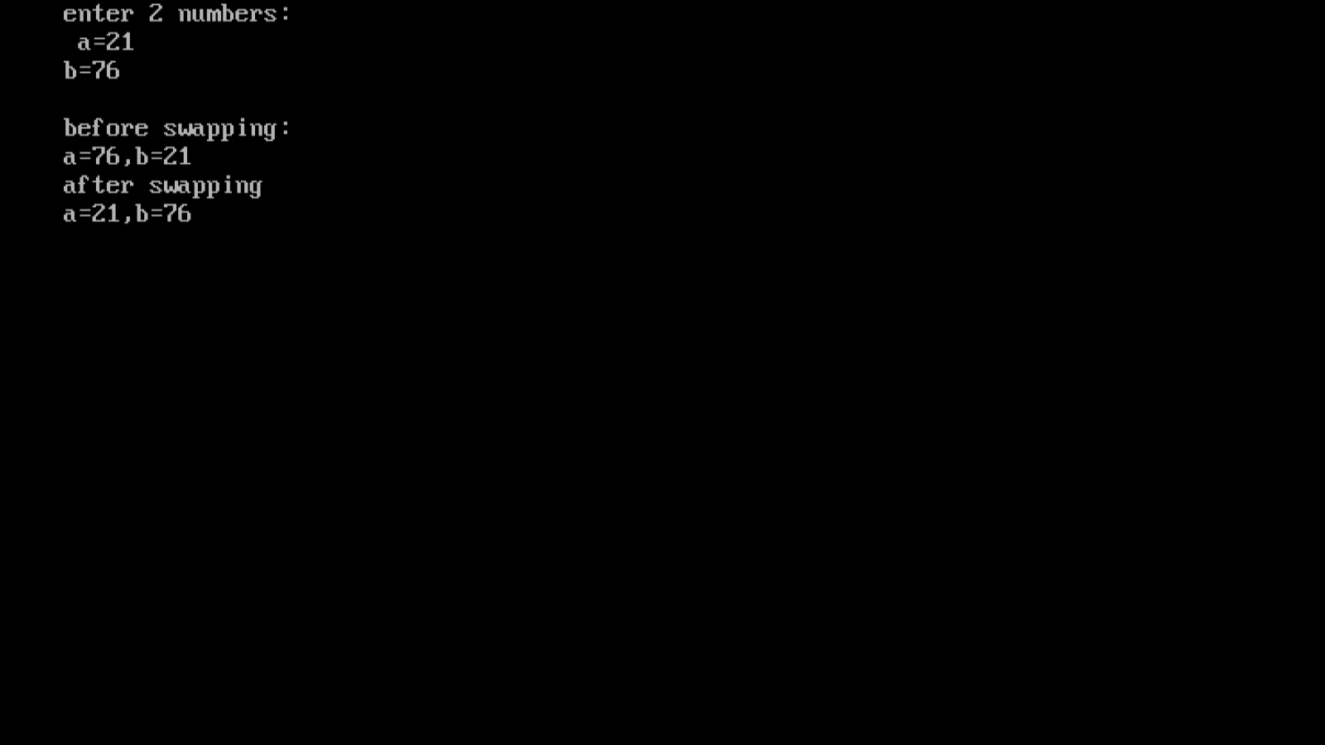

***Program.30:-*** **write a program in C to find the Area of a circle using call by reference.**

**Source code:-**

#include<stdio.h>

#include<conio.h>

void circle(int*);

void main(){

int r;

clrscr();

printf("enter the radius of circle:\n");

scanf("%d",&r);

circle(&r);

getch();

}

void circle(int *r){

float *ar,*c,pi=3.14;

*ar=pi**r**r;

*c=2*pi**r;

printf("area of circle=%f\nparameter=%f",*ar,*c);

}

**Output:-**

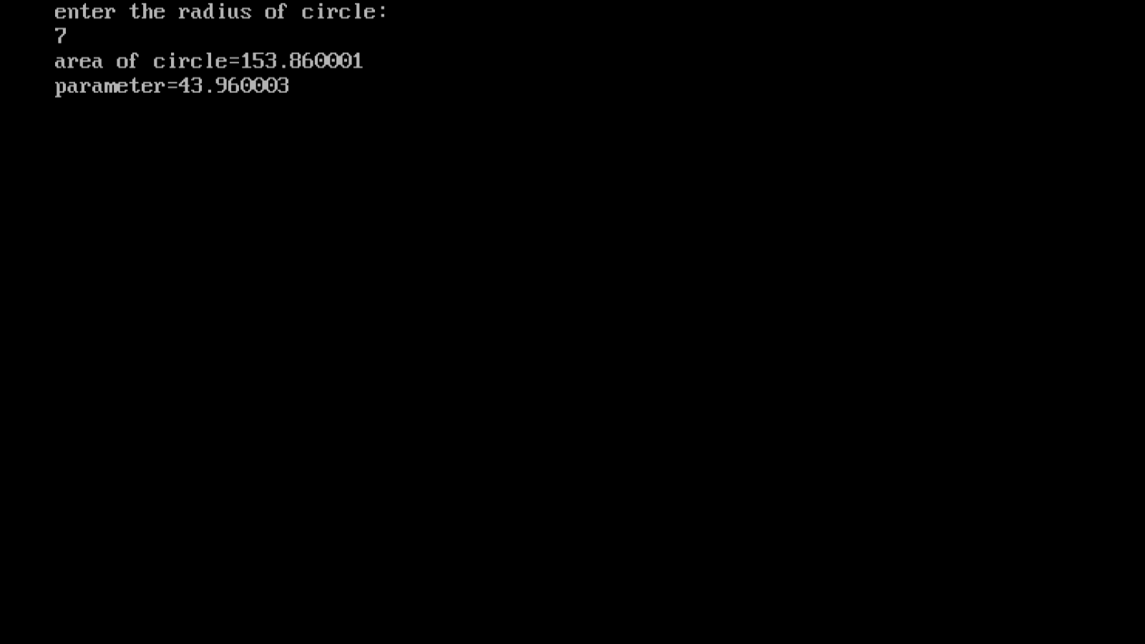

***Program.31:-*** **Write a program to add, subtract, multiply and divide two numbers using pointers and Using function.**

**Source code:-**

#include<stdio.h>

#include<conio.h>

void main(){

int a,b,*p,*q,sum,s,m;

float div;

printf("enter two numbers:- ");

scanf("%d %d",&a,&b);

p=&a;

q=&b;

sum=*p + *q;

s=*p - *q;

m=*p * *q ;

div=(float)*p / *p;

printf("addition= %d \n",sum);

printf("subtraction= %d \n",s);

printf("multiplication= %d \n",m);

printf("division= %d \n",div);

getch();

}

**Output:-**

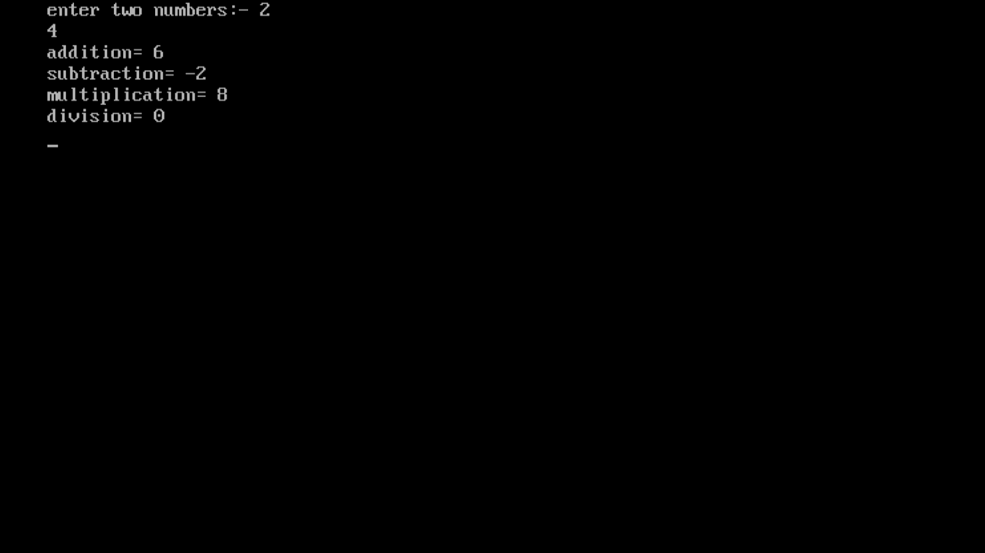

***Program.32:-*** write a program to input marks of 50 students using an Array and display the Average marks of the class.

**Source code:-**

*#include<stdio.h>*

*#include<conio.h>*

*void main(){*

*float avg;*

*long int i,sum=0;*

*long int marks[50];*

*clrscr();*

*printf("enter the marks of 50 students:\n");*

*for(i=0;i<50;i++){*

*scanf("%ld",&marks[i]);}*

*for(i=0;i<50;i++){*

*sum=sum+marks[i];}*

*avg=sum/50;*

*printf("\naverage marks =%f",avg);*

*getch();*

*}*

***Output:-***

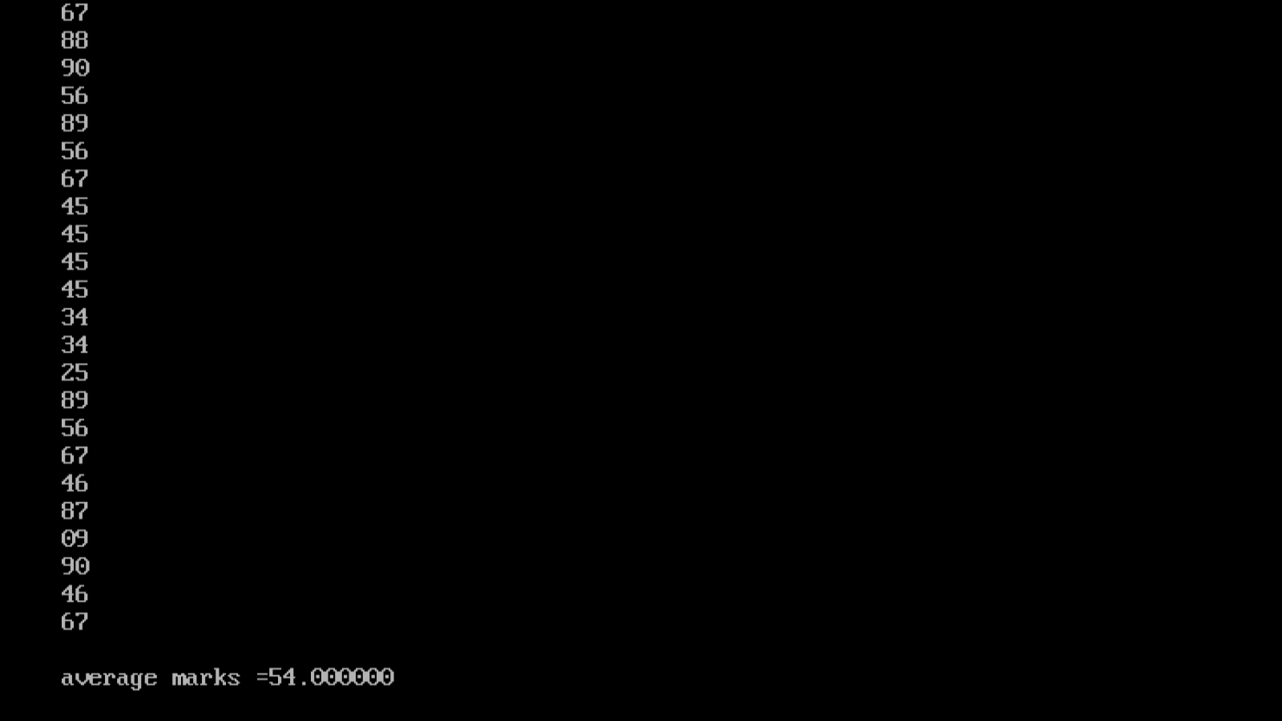

***Program.33:-*** **Write a program to search for a number entered by the user in a given array.**

**Source code:-**

#include<stdio.h>

int main(){

int num,n[10],i;

printf("Enter 10 number ");

for (int i = 0; i <10; i++){

scanf("%d",&n[i]);

    }

printf("Enter your number you want to search in list ");

scanf("%d",&num);

for ( i = 0; i <10; i++)

    {

        if (num==n[i]){

            printf("number is found \n");

            break;

        }

    }

    printf("when your num not found  print nothing");

    return 0;

}

**Output:-**

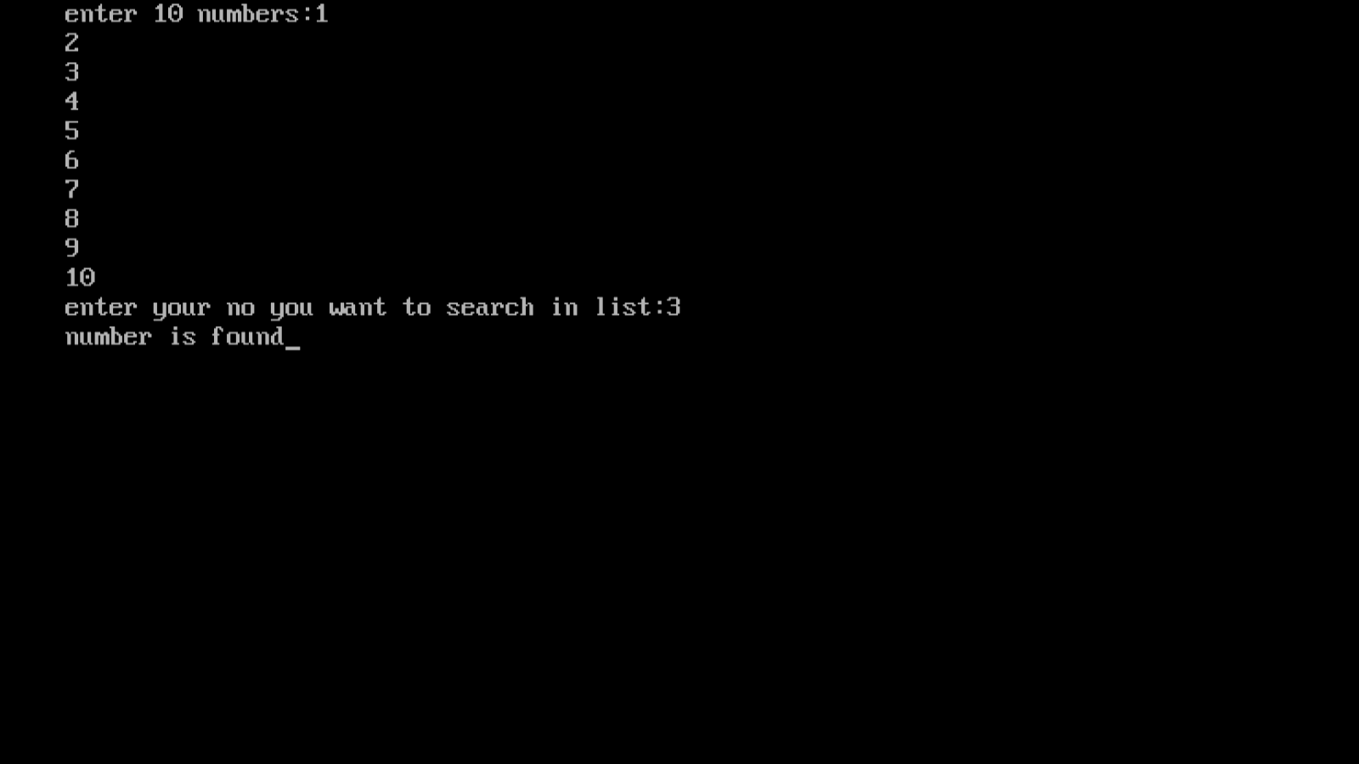

***Program.34:-*** **write a program in C to pass array elements to a function.**

**Source code:-**

#include<stdio.h>

#include<conio.h>

void display(int);

int main(){

int i;

int marks[]={11,22,33,44,55};

clrscr();

for(i=0;i<5;i++){

display(marks[i]);

}

return 0;

}

void display(int m){

printf("%d\n",m);

}

**Output:-**

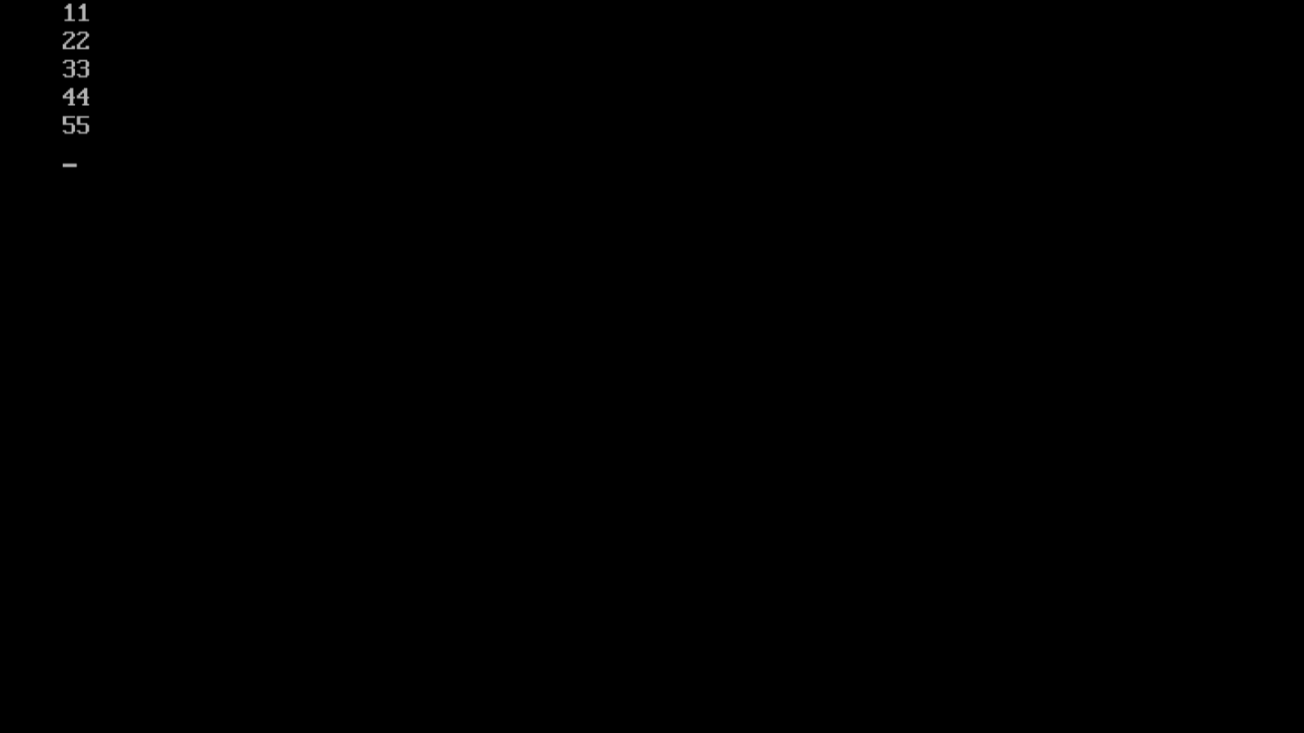

**Program.35- Program: Write a program in C to print the following pattern.**

**\***

**\*\***

**\*\*\***

**\*\*\*\***

**\*\*\*\*\***

**Source code:-**

#include<stdio.h>

#include<conio.h>

int main(){

int i,j,n,no;

clrscr();

printf("enter no of rows:");

scanf("%d",&no);

for(i=0;i<no;i++){

for(j=0;j<=i;j++){printf("*");}

printf("\n");

}

return 0;

}

**Output:-**

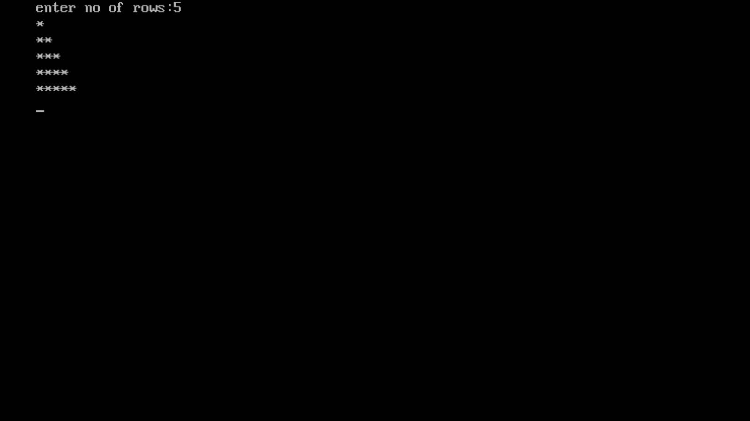

**Program.36:-** Write a program in C to print the Inverted half pyramid of *

**\*\*\*\*\***

**\*\*\*\***

**\*\***

**Source code:-**

#include<stdio.h>

#include<conio.h>

int main(){

int i,j,rows;

clrscr();

printf("enter the number of rows:");

scanf("%d",&rows);

for(i=rows;i>=1;i--){

for(j=1;j<=i;j++){printf("*");}

printf("\n");

}

return 0;

}

**Output:-**

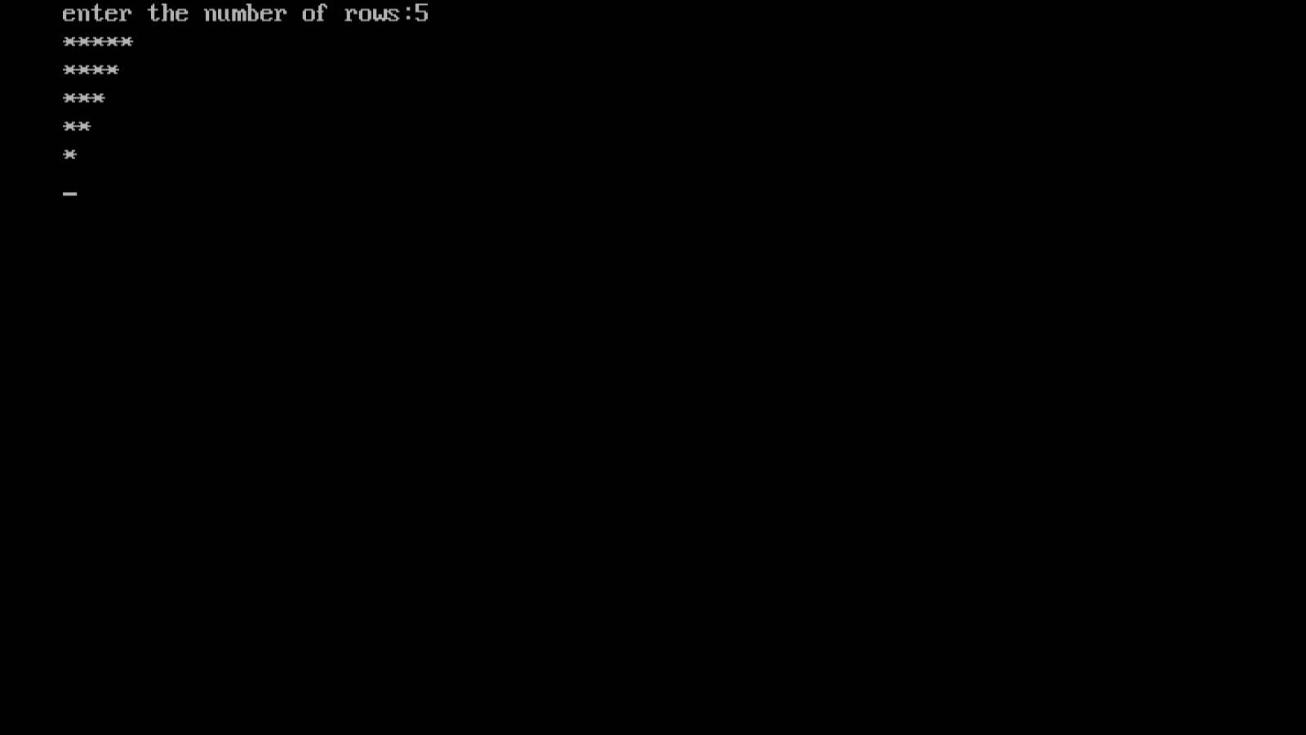

**Program.37:-** **Write a program in C to print the Half Pyramid of Numbers.** 1

1 2

1 2 3

1 2 3 4

**Source code:-**

#include<stdio.h>

#include<conio.h>

int main(){

int i,j,row;

clrscr();

printf("enter the number of rows:");

scanf("%d",&row);

for(i=1;i<=row;i++){

for(j=1;j<=i;j++){printf("%d",j);}

printf("\n");

}

return 0;

}

**Output:-**

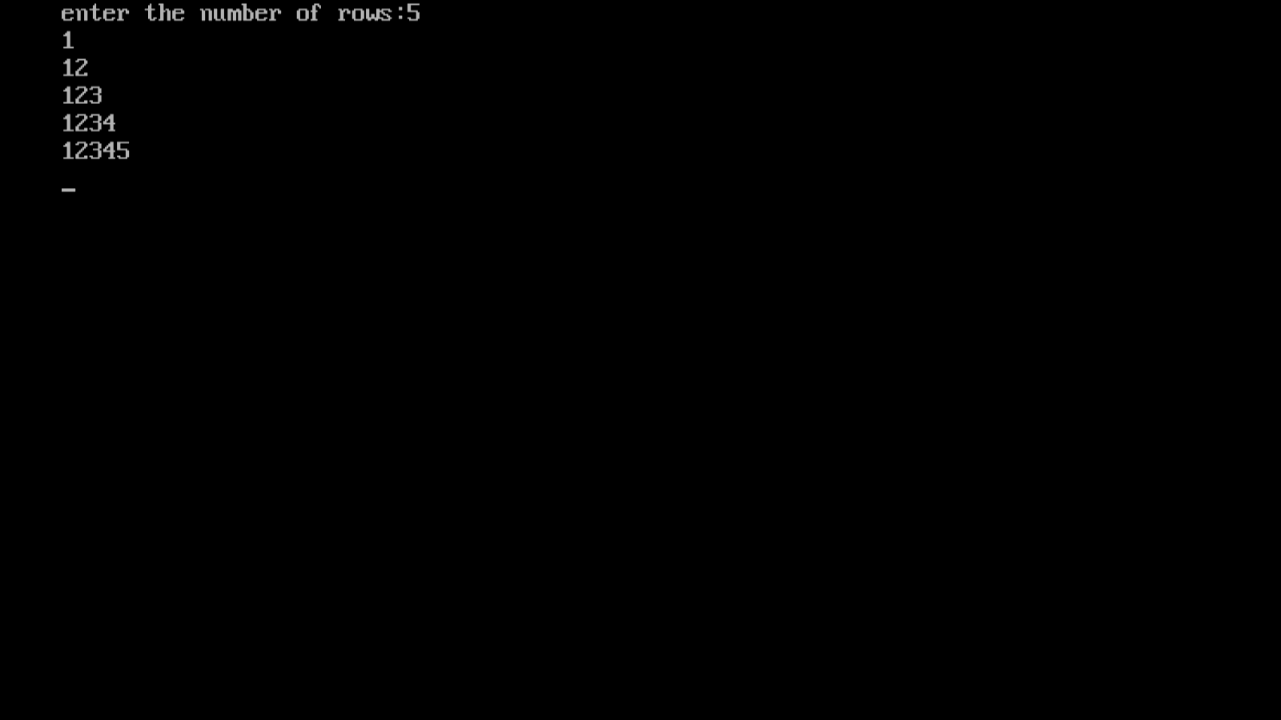

**Program.38:-** **Write a program in C to print the full-Pyramid of Numbers.**

**Source code:-**

#include<stdio.h>

#include<conio.h>

int main(){

int i,j,k,rows,n=1;

clrscr();

printf("enter the number of rows:");

scanf("%d",&rows);

for(i=0;i<=rows;i++){

for(k=0;k<=rows-i;k++){printf(" ");}

for(j=0;j<=(1*i-1);j++){printf("%d",n); ++n;}

printf("\n");

}

return 0;

}

**Output:-**

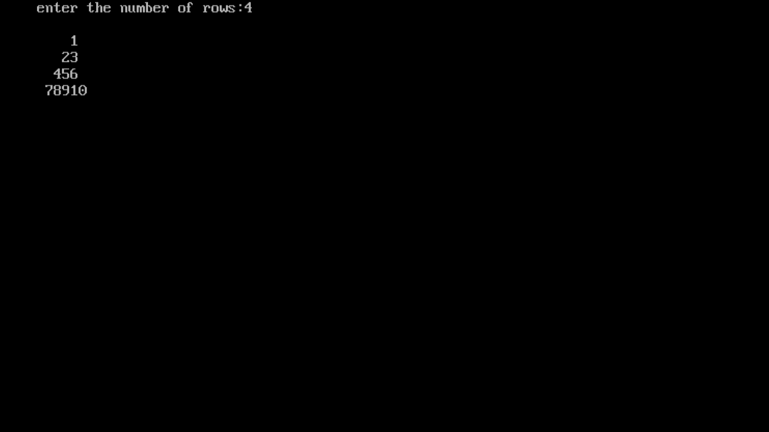

**Program.39:-write a program using pointer to compute the sum of all elements Stored in the Array.**

***Source code:-***

*#include<stdio.h>*

*#include<conio.h>*

*int main(){*

*int arr[5];*

*int sum=0,*p,i,j=0;*

*printf("enter 5 elements:");*

*for(i=0;i<5;i++){*

*scanf("%d",&arr[i]);*

*}*

*p=arr;*

*while(j<5){*

*printf("\n %d. %d",j,*p);*

*sum=sum+*p;*

*j++;*

*p++;*

*}*

*printf("\n sum of all elements:%d",sum);*

*return 0;*

*}*

***Output:-***

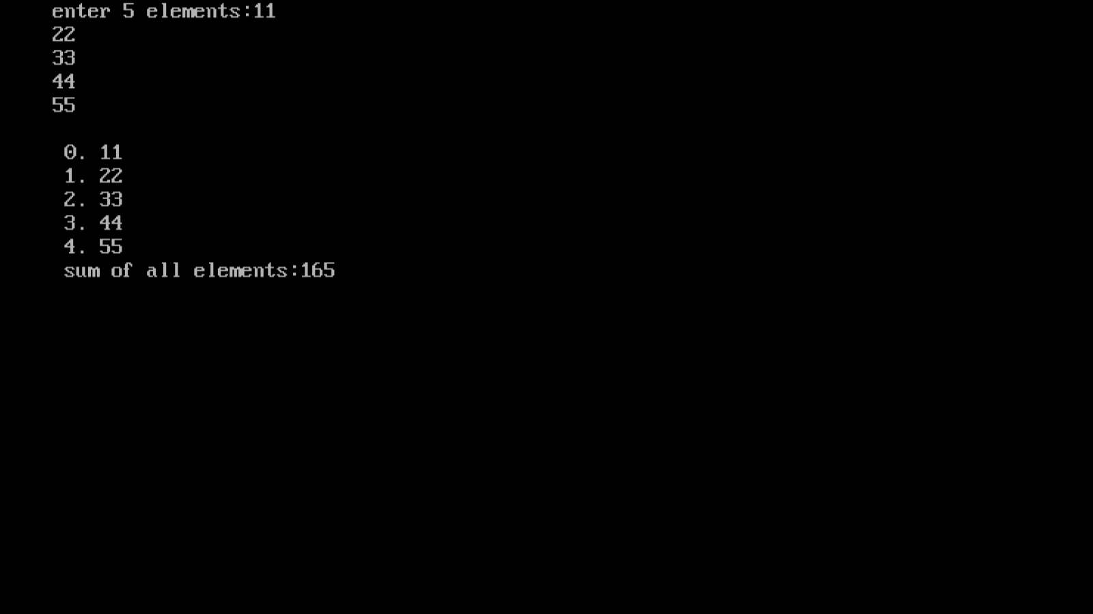

***Program.40:* Write a program in C to sort the elements of an array using pointers.**

***Source code:-***

*#include<stdio.h>*

*#include<conio.h>*

*void sort(int,int*);*

*int main(){*

*int n=5;*

*int a[]={0,23,43,16,9};*

*clrscr();*

*sort(n,a);*

*return 0;*

*}*

*void sort(int m,int*p){*

*int i,j,temp;*

*for(i=0;i<m;i++){*

*for(j=i+1;j<m;j++){*

*if(*(p+j)<*(p+i)){*

*temp=*(p+i);*

*\*(p+i)=*(p+j);*

*\*(p+j)=temp; }*

*}*

*}*

*for(i=0;i<m;i++){printf("\t%d",*(p+i));}*

*}*

***Output:-***

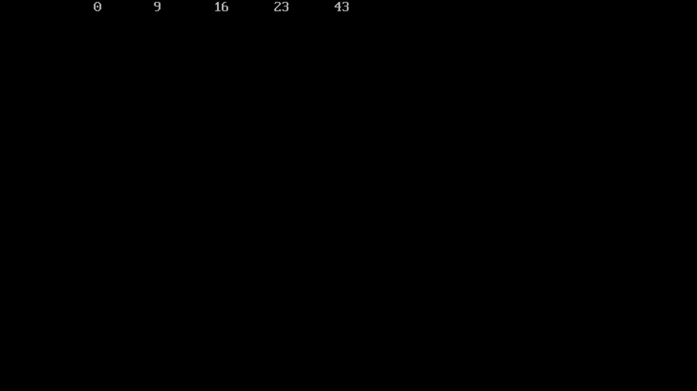

***Program.41:-*** **Write a program for the use of malloc and free function**

**Source code:-**

*#include<stdio.h>*

*#include<conio.h>*

*#include<alloc.h>*

*void main(){*

*char *ch;*

*int *p;*

*float *f;*

*ch=(char*)malloc(sizeof(char));*

*p=(int*)malloc(sizeof(int));*

*f=(float*)malloc(sizeof(float));*

*printf("enter a character");*

*\*ch=getchar();*

*printf("enter a integer");*

*scanf("%d",p);*

*printf("enter a float");*

*scanf("%f",f);*

*printf("U entered\n%c %d %f",*ch,*p,*f);*

*free(ch);*

*free(p);*

*free(f);*

*}*

***Output:-***

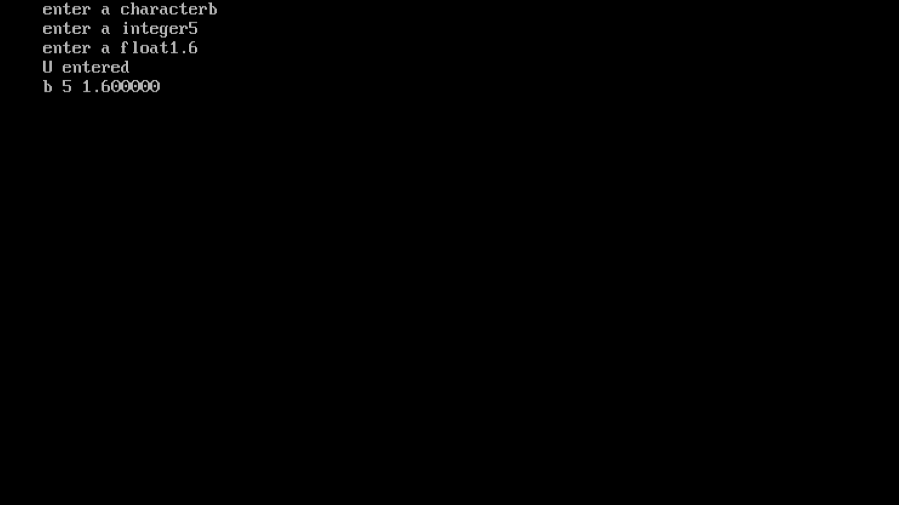

***Program.42* :-Write a program to show the concept of dynamic memory allocation for an array**

***Source code:-***

*#include<stdio.h>*

*#include<conio.h>*

*#include<alloc.h>*

*void main(){*

*int *p,n,i;*

*printf("enter the size of array:");*

*scanf("%d",&n);*

*p=(int*)malloc(sizeof(int)*n);*

*for(i=0;i<n;i++){*

*printf("\n enter p[%d] element",i);*

*scanf("%d",p+i);*

*}*

*printf("array elements are:");*

*for(i=0;i<n;i++){*

*printf("p[%d]=%d\n",i,*(p+i));*

*}*

*free(p);*

*}*

***Output:-***

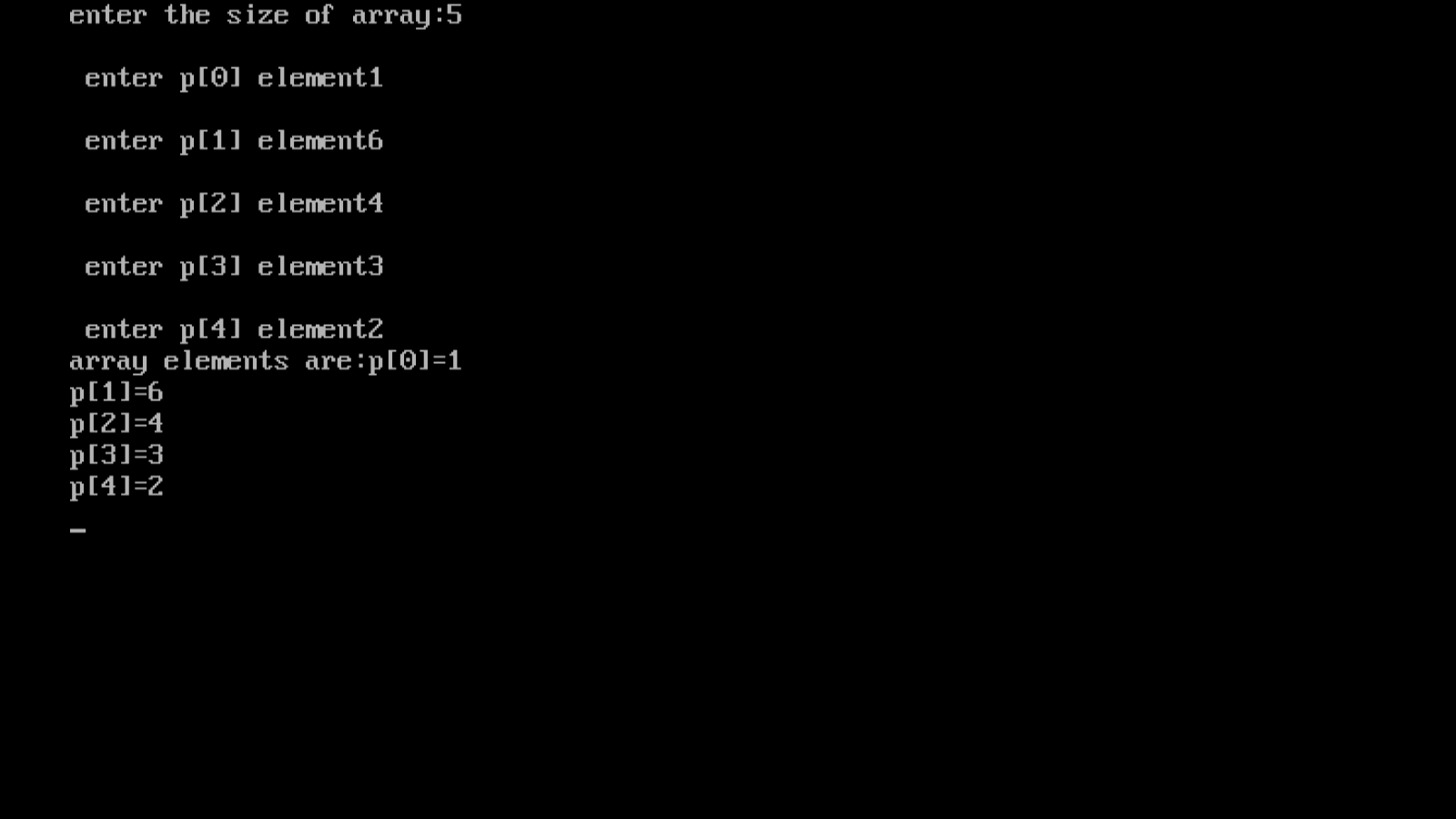

***Program.43* :-** **Write a program to perform matrix addition, multiplication and transpose**

**Source code:-**

*#include<stdio.h>*

*#include<conio.h>*

*void add(int m[3][3],int n[3][3],int sum[3][3]);*

*void multiply(int m[3][3],int n[3][3],int mul[3][3]);*

*void transpose(int matrix[3][3],int trans[3][3]);*

*void display(int matrix[3][3]);*

*void main(){*

*int a[][3]={{5,6,7},{8,9,10},{11,12,13}};*

*int b[][3]={{1,3,7},{2,4,6},{4,12,8}};*

*int c[3][3];*

*int choice;*

*clrscr();*

*printf("first matrix:\n");*

*display(a);*

*printf("second matrix:\n");*

*display(b);*

*do{*

*printf("\n choose matrix opperations:-\n");*

*printf("1.addition\n");*

*printf("2.multiplication");*

*printf("3.transpose");*

*printf("4.exit\n");*

*printf("____________________\n");*

*printf("enter your choice:");*

*scanf("%d",&choice);*

*switch(choice){*

*case 1:*

*add(a,b,c);*

*printf("sum of matrix:\n");*

*display(c);*

*break;*

*case 2:*

*multiply(a,b,c);*

*printf("multiplication of matrix:\n");*

*display(c);*

*break;*

*case 3:*

*printf("transpose of 1st matrix:\n");*

*transpose(a,c);*

*display(c);*

*printf("transpose of 2nd matrix:\n");*

*transpose(b,c);*

*display(c);*

*break;*

*case 4:*

*printf("thank you.\n");*

*exit(0);*

*default:*

*printf("wrong choice");*

*}*

*}*

*while(1);*

*}*

*void add(int m[3][3],int n[3][3],int sum[3][3]){*

*int i,j;*

*for(i=0;i<3;i++)*

*for(j=0;j<3;j++)*

*sum[i][j]=m[i][j]+n[i][j];*

*}*

*void multiply(int m[3][3],int n[3][3],int mul[3][3]){*

*int i,j,k;*

*for(i=0;i<3;i++)*

*for(j=0;j<3;j++)*

*{*

*mul[i][j]=0;*

*for(k=0;k<3;k++){*

*mul[i][j]+=(m[i][k]*n[k][j]);*

*}}}*

*void transpose(int matrix[3][3],int trans[3][3]){*

*int i,j;*

*for(i=0;i<3;i++)*

*for(j=0;j<3;j++)*

*trans[i][j]=matrix[j][i];*

*}*

*void display(int matrix[3][3]){*

*int i,j;*

*for(i=0;i<3;i++)*

*{*

*for(j=0;j<3;j++)*

*printf("%d\t",matrix[i][j]);*

*printf("\n");*

*}*

*}*

***Output:-***

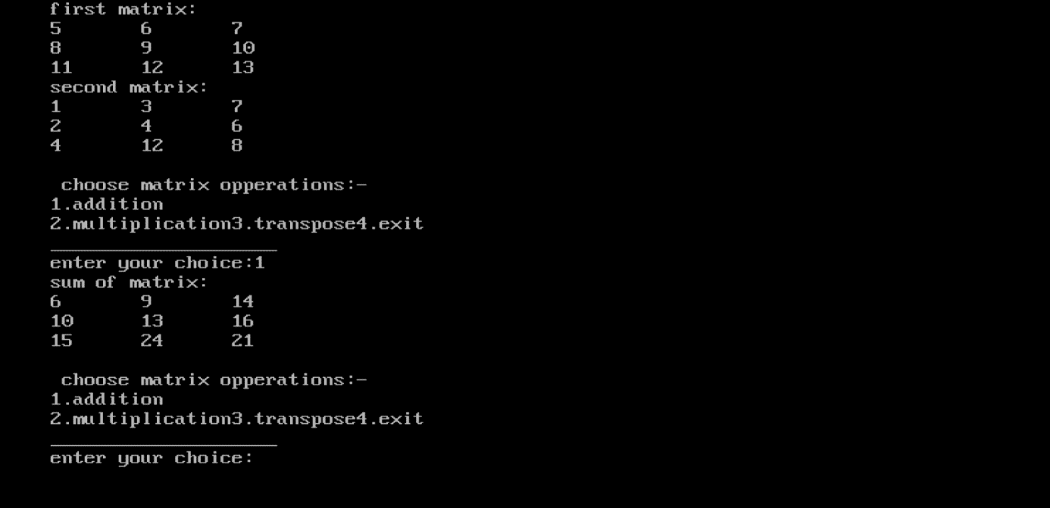

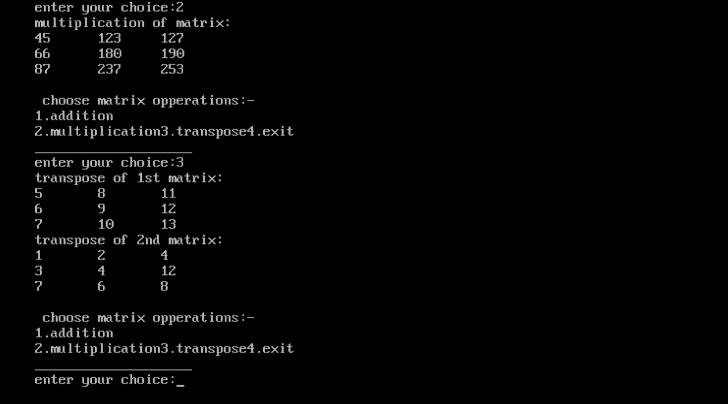

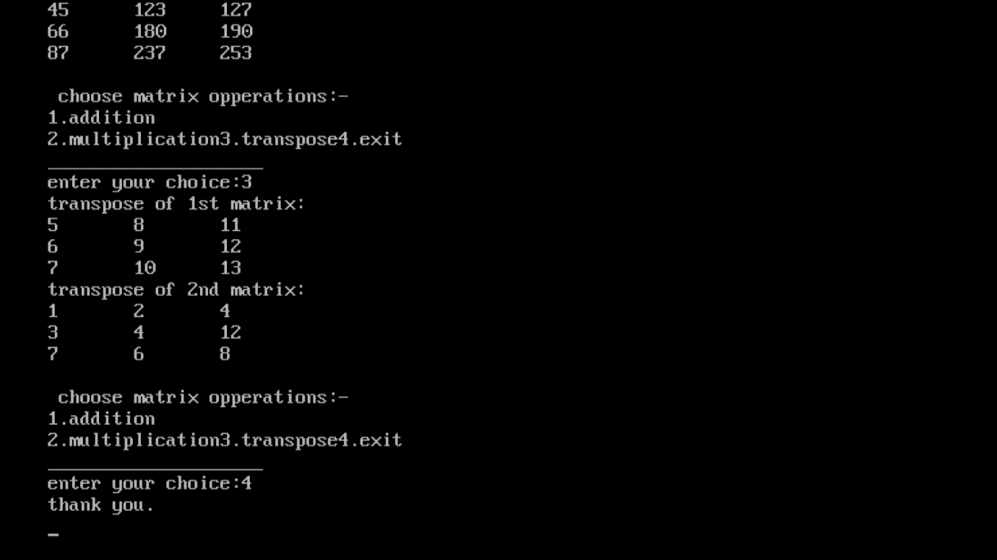

***Program.44:-* Write a program to check if string is a palindrome or not ,using predefined function strcpy**

**Source code:-**

#include<stdio.h>

#include<conio.h>

#include<string.h>

int main(){

char s1[1000],s2[1000];

printf("enter the strings: ");

gets(s1);

strcpy(s2,s1);

strrev(s2);

if(!strcmp(s1,s2))

printf("string is palindrome");

else

printf("string is not palindrome");

return 0;

}

**Output:-**

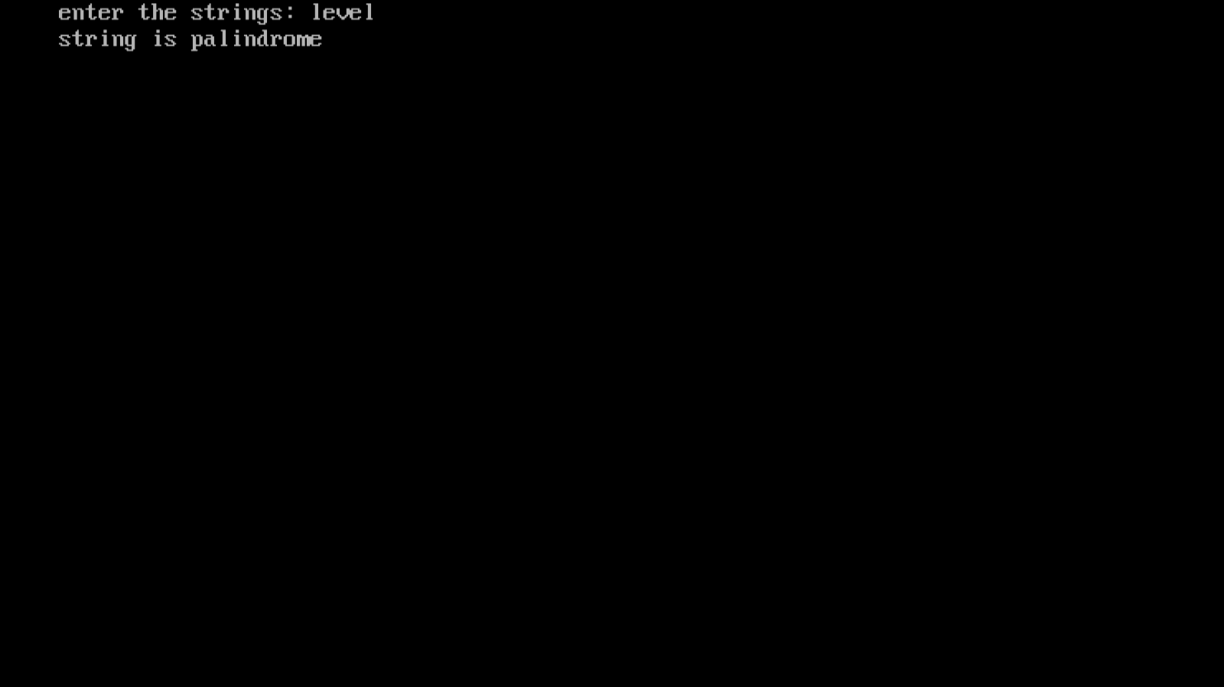

***Program.45:-*** **Write a program to check if string is a palindrome or not ,without using predefined function.**

**Source code:-**

#include<stdio.h>

#include<conio.h>

#include<string.h>

int main(){

char s[1000];

int i,n,c=0;

printf("enter the string:");

gets(s);

n=strlen(s);

for(i=0;i<n/2;i++){

if(s[i]==s[n-i-1])

c++;}

if(c==i)

printf("string is palindrome");

else

printf("string is not palindrome");

return 0;

}

**Output:-**

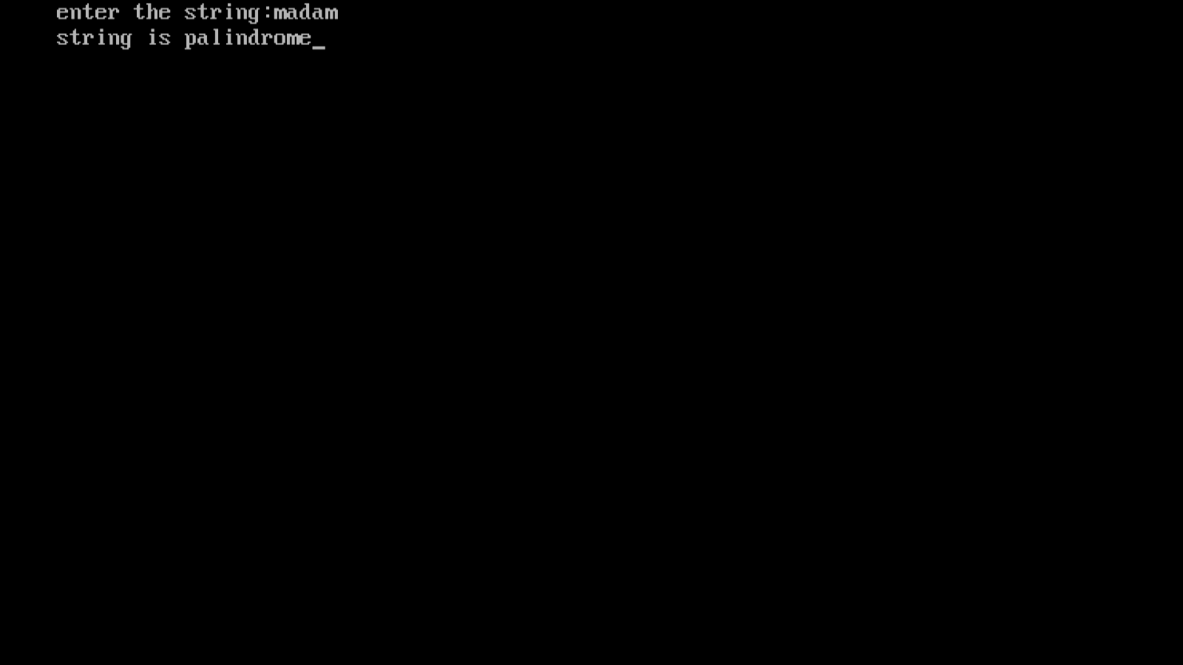

**Program.46:- Write a menu driven program to implement following operations:**

**(i) Calculate length of string**

**(ii) Concatenate at the end of a given string**

**(iii) Copy one string to another**

**(iv) Compare contents of two strings**

**(v) Copy nth character string to another.**

**Source code:-**

#include<stdio.h>

#include<conio.h>

#include<string.h>

#include<stdlib.h>

int main(){

char str1[20],str2[20];

int choice,I,j;

do

{

printf("\tMENU");

printf("\n----------------------\n");

printf("1. Calculate length of string");

printf("\n2. Concatenate at the end of a given string");

printf("\n3. Copy one string to another");

printf("\n4. Compare contents of two strings");

printf("\n5. Copy nth character string to another");

printf("\n6. Exit");

printf("\n------------------------\n");

printf("\nEnter your choice: ");

scanf("%d",&choice);

switch(choice)

{

case 1:

printf("enter string: ");

scanf("%s",str1);

I=strlen(str1);

printf("length of string - %d\n",I);

break;

case 2:

printf("\nEnter First String: ");

scanf("%s",str1);

printf("Enter Second string: ");

scanf("%s",str2);

strcat(str1,str2);

printf("String After Concatenation : %s\n\n",str1);

break;

case 3:

printf("Enter a String1: ");

scanf("%s",str1);

printf("Enter a String2: ");

scanf("%s",str2);

printf("\nString Before Copied:\nString1=\"%s\",String2=\"%s\"\n",str1,str2);

strcpy(str2,str1);

printf("-----------------------------------------------\n");

printf("\"We are copying string String1 to String2\" \n");

printf("-----------------------------------------------\n");

printf("String After Copied:\nString1=\"%s\", String2=\"%s\"\n\n",str1,str2);

break;

case 4:

printf("Enter First String: ");

scanf("%s",str1);

printf("Enter Second String: ");

scanf("%s",str2);

j=strcmp(str1,str2);

if(j==0)

{

printf("Strings are Same\n\n");

}

else

{

printf("Strings are Not Same\n\n");

}

break;

case 5:

char text1[20];

char text2[20];

int i;

printf("Enter any string: ");

gets(text1);

for(i=0; text1[i]!='\0'; i++)

{

text2[i] = text1[i];

}

text2[i] = '\0';

printf("First string = %s\n", text1);

printf("Second string = %s\n", text2);

printf("Total characters copied = %d\n", i);

break;

case 6:

exit(0);

break;

default: printf("invalid input.please enter valid input.\n" );

}

}

while(choice!=6);

return 0;

}

**Output:-**

**Program.47:- Write a program to find factorial using recursion**

**Source code:-**

#include<stdio.h>

#include<conio.h>

long int multiplyno(int n);

int main(){

int n;

clrscr();

printf("enter a positive integer: ");

scanf("%d",&n);

printf("factorial of %d=%d",n,multiplyno(n));

return 0;

}

long int multiplyno(int n){

if(n>=1)

return n*multiplyno(n-1);

elsess

return 1;

}

**Output:-**

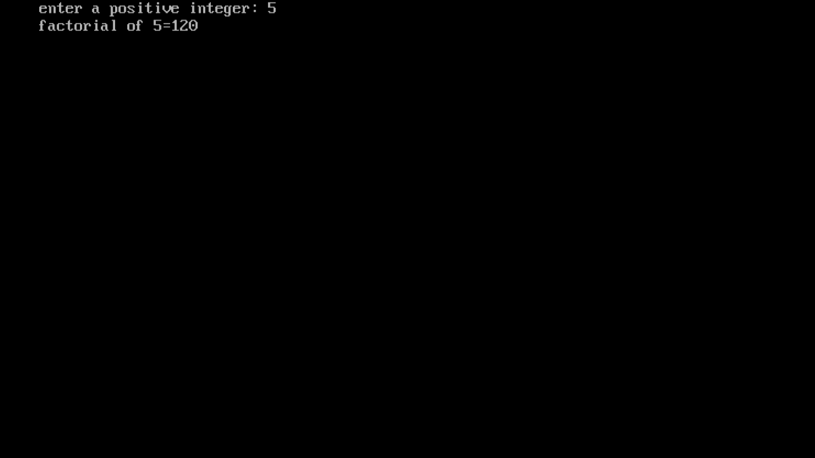

**Program.48:- Write a program to convert hexadecimal into binary number.**

**Source code:-**

#include <stdio.h>

#include <string.h>

int main()

{

char hex[17], bin[65] = "";

int i = 0;

printf("Enter any hexadecimal number: ");

gets(hex);

for(i=0; hex[i]!='\0'; i++)

{

switch(hex[i])

{

case '0':

strcat(bin, "0000");

break;

case '1':

strcat(bin, "0001");

break;

case '2':

strcat(bin, "0010");

break;

case '3':

strcat(bin, "0011");

break;

case '4':

strcat(bin, "0100");

break;

case '5':

strcat(bin, "0101");

break;

case '6':

strcat(bin, "0110");

break;

case '7':

strcat(bin, "0111");

break;

case '8':

strcat(bin, "1000");

break;

case '9':

strcat(bin, "1001");

break;

case 'a':

case 'A':

strcat(bin, "1010");

break;

case 'b':

case 'B':

strcat(bin, "1011");

break;

case 'c':

case 'C':

strcat(bin, "1100");

break;

case 'd':

case 'D':

strcat(bin, "1101");

break;

case 'e':

case 'E':

strcat(bin, "1110");

break;

case 'f':

case 'F':

strcat(bin, "1111");

break;

default:

printf("Invalid hexadecimal input.");

}

}

printf("Hexademial number = %s\n", hex);

printf("Binary number = %s", bin);

return 0;

}

**Output:-**

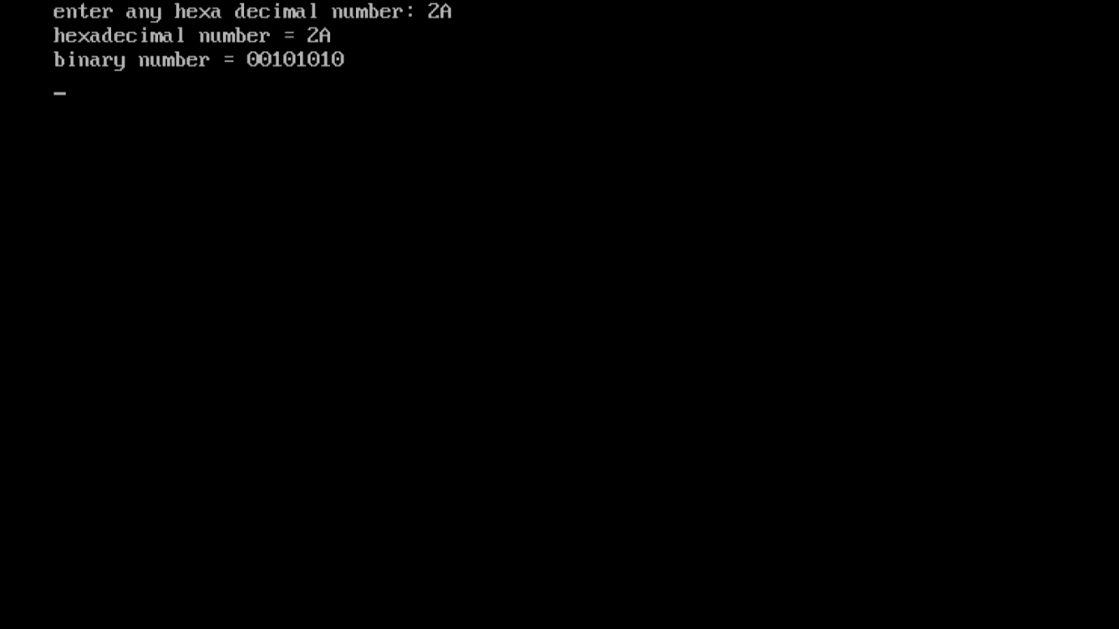

**Program.49:-** Write a program to implement pointer to function

**Source code:-**

#include<stdio.h>

#include<conio.h>

void fun(int a)

{

printf("value of a is %d\n",a);

}

int main()

{

void(*fun_ptr)(int) = fun;

clrscr();

fun_ptr(10);

getch();

}

**Output:-**

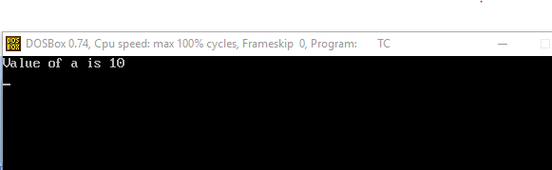

**Program.50:-** Write a Program to pass address of structure variable to a user defined function and display the content.

SOURCE CODE:

void display(st#include<stdio.h>

struct book

{

    char name[50];

    char Author[40];

    int Pages;

};

ruct book *ba);

int main(){

    struct book b1 = {"Shehbaz","code_Power_Harry",10};

    display(&b1);

    printf("size of b1 is %d",sizeof(b1));

printf("size of b1 is %d\n",sizeof(b1.name));

    printf("size of b1 is %d\n",sizeof(b1.Author));

    printf("size of b1 is %d\n",sizeof(b1.Pages));

    return 0;

}

void display(struct book *ba ){

    printf("%s\n",ba->name);

    printf("%s \n",ba->Author);

    printf("%d \n",ba->Pages);

}

**Output:-**

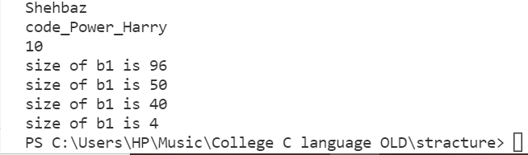

PROGRAM:-51**:-** Write a program to make use of arrays with structures in the following ways:

1. Use array as a structure data member
2. Create array of structure variables

SOURCE CODE:

#include<stdio.h>

struct student

{

    char name[100];

    int Age,ID;

};

int main(){

    struct student stu[3];

    for (int i = 0; i <3; i++)

    {

    printf("Enter three student[%d]  info like name Age ID \n",i);

        scanf("%s%d%d",stu[i].name,&stu[i].Age,&stu[i].ID);

    }

    for (int i = 0; i <3; i++)

    {

        printf("Student[%d] NAME is %s \n",i,stu[i].name);

        printf("Student[%d] Age is %d \n",i,stu[i].Age);

        printf("Student[%d] student id is %d \n",i,stu[i].ID);

    }

    return 0;

}

**Output:-**

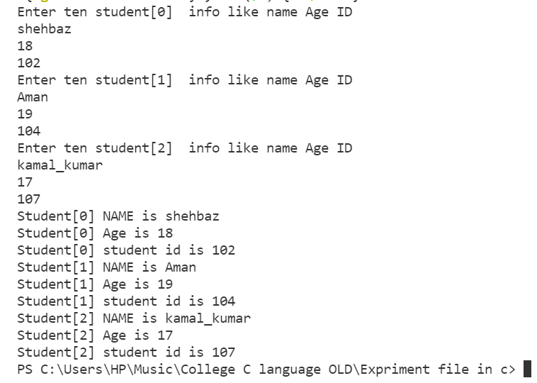

PROGRAM:-52**:-** Write a program to fill student information by using #define and macros.

SOURCE CODE:

#include<stdio.h>

#include<conio.h>

#define ind 1

#define usa 2

#define uk 3

#define country uk

void main()

{

clrscr();

#if country==ind

printf("Selectd country code is: %d\n",country);

#elif country==usa

printf("Selected country is: %d\n",country);

#else

printf("Selected country is: %d",country);

#endif

getch();

}

**OUTPUT:**

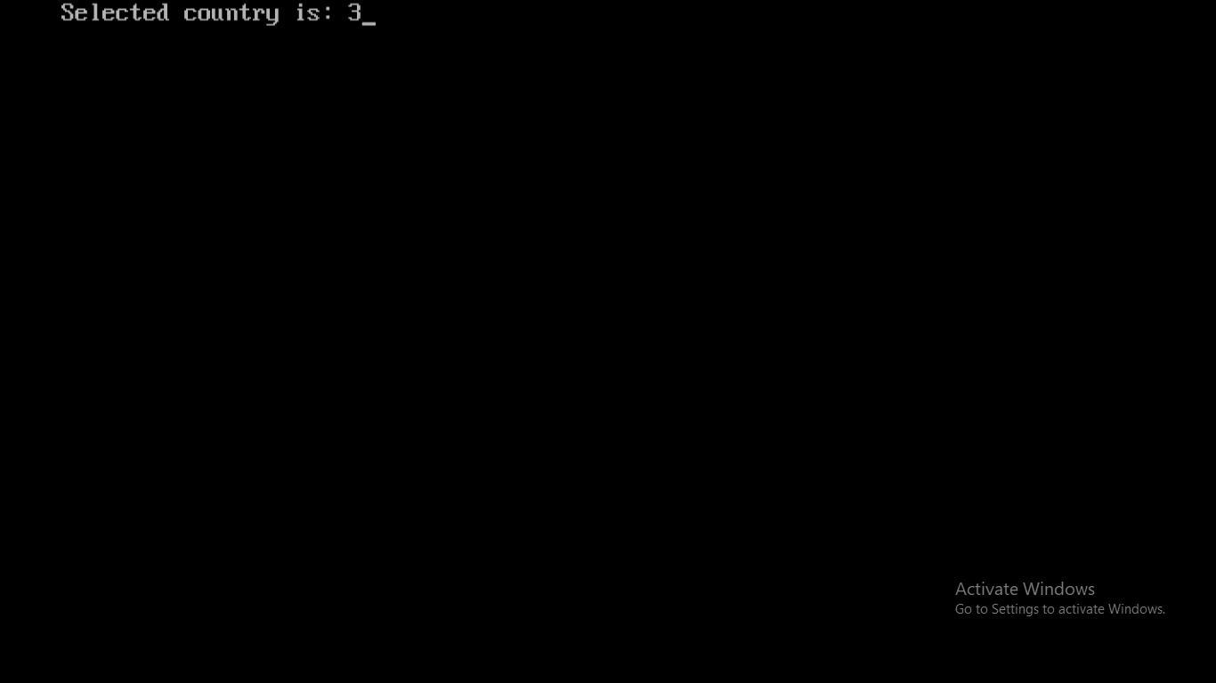

PROGRAM:-53**:-** Write a program to print number till 10 using #if and #else.

**Source Code:**

#include<stdio.h>

#include<conio.h>

#define ind 1

#define usa 2

#define uk 3

#define country uks

void main(){

clrscr();

#if country==ind

printf("Selectd country code is: %d\n",country);

#elif country==usa

printf("Selected country is: %d\n",country);

#else

printf("Selected country is: %d",country);

#endif

getch();

}

**OUTPUT:**

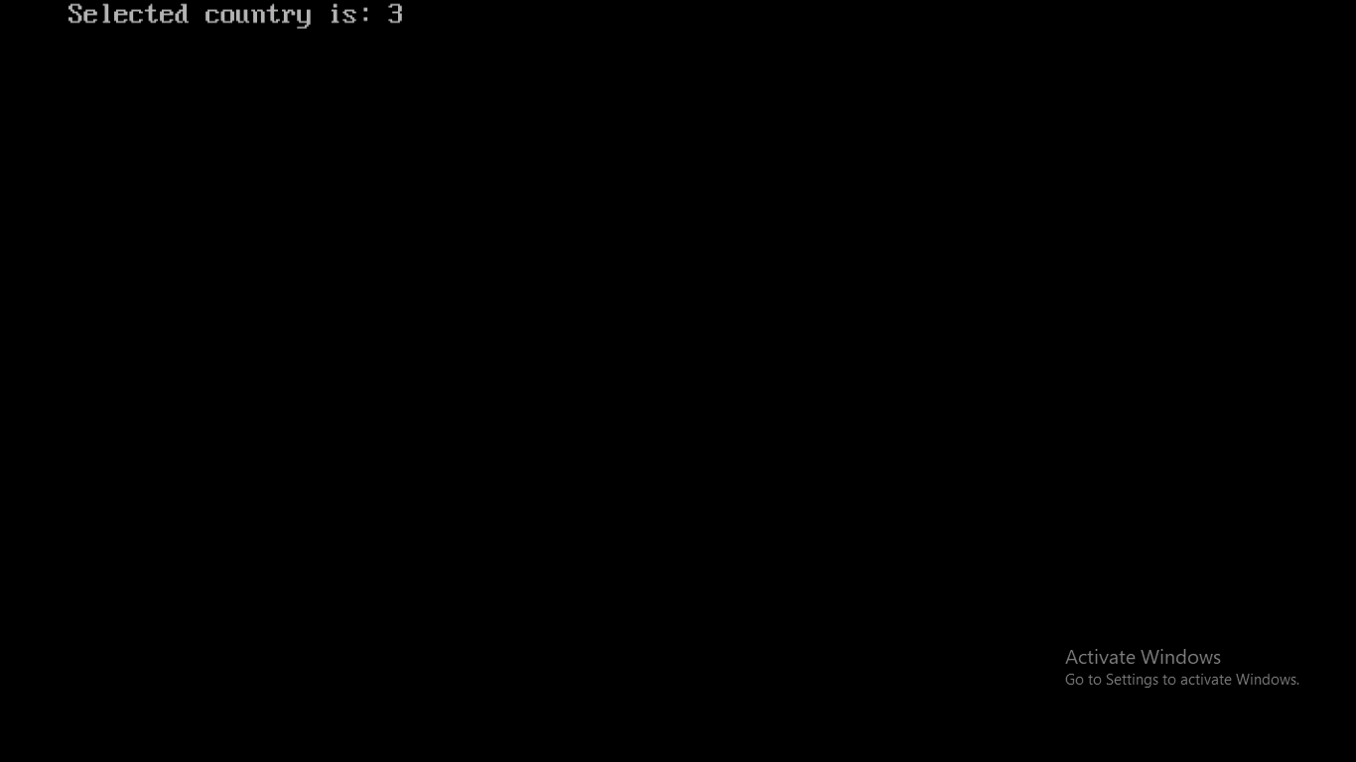

PROGRAM:-54**:-** Write a programe to Store information of 10 students using structures

**Source Code:**

#include<stdio.h>

#include<conio.h>

#include<stdlib.h>

struct std

{

char name[20];

int rollno;

int age;

};

void main(){

struct std s[10];

int i,n;

clrscr();

for(i=0;i<10;i++)

{

printf("enter the details of students");

printf("\n roll no of student");

scanf("%d",s[i].rollno);

printf("\n enter name of student");

scanf("%s",&s[i].name);

printf("\n enter age of student");

scanf("%d",s[i].age);

}

for(i=0;i<10;i++)

{

printf("\n name:%s",s[i].name);

printf("\n age :%d",s[i].age);

printf("\n rollno:%d",s[i].rollno);

}

getch();}

**OUTPUT:**

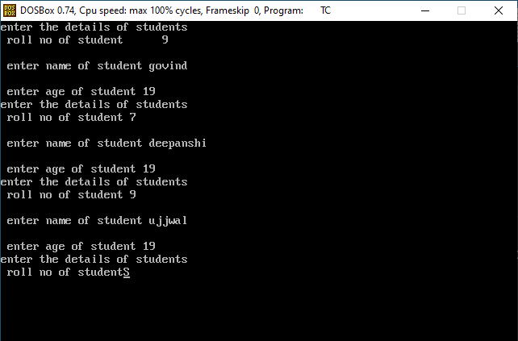

PROGRAM:-55**:-** Write a program to compare two strings.

**Source Code:**

#include <stdio.h>

#include <string.h>

void main(){

char str1[] = "abcd", str2[] = "abcd", str3[] = "abcd";

int result;

clrscr();

result = strcmp(str1, str2);

printf("strcmp(str1, str2) = %d\n", result);

result = strcmp(str1, str3);

printf("strcmp(str1, str3) = %d\n", result);

getch();}

**OUTPUT :-**

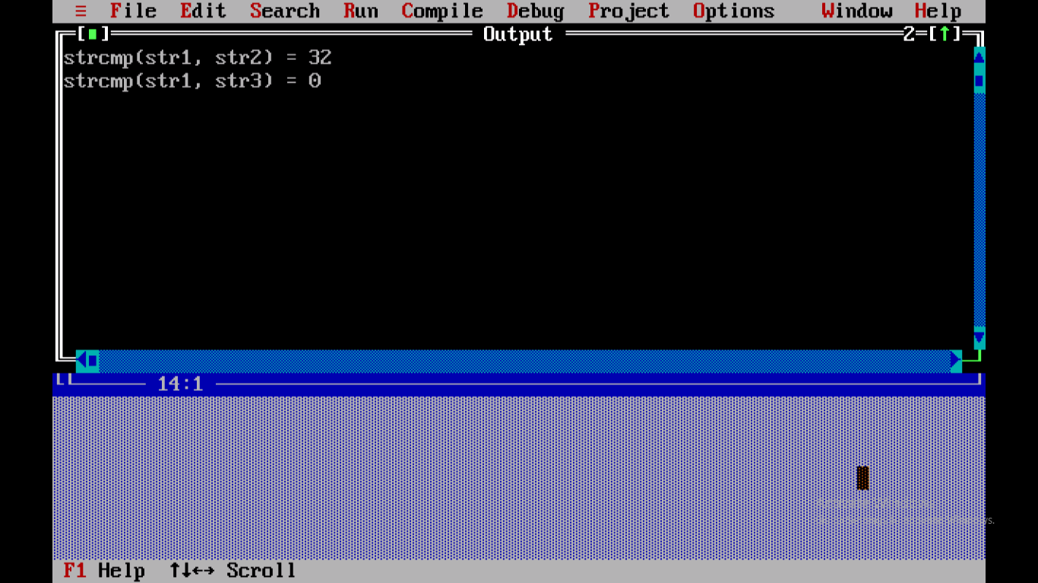

PROGRAM:-56**:-** write A program to open a text file an Write Some text using fprintf and fscanf functions.

SOURCE CODE:

#include<stdio.h>

int main(){

    FILE *ptr;

    char text[30];

    int age;

    ptr = fopen("hello.txt","w");

    printf("Enter text in your File ");

    gets(text);

    fprintf(ptr,"%s",text);

    fclose(ptr);

    ptr = fopen("hello.txt","r");

    fscanf(ptr,"%s%d",text,&age);

    printf("name of Student %s ,and Age is %d \n",text,age);

    fclose(ptr);

    return 0;

}

**Output:-**

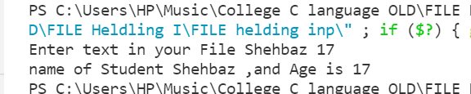

PROGRAM:- 57**:-** Write a program to implement fopen() and fclose() function in file handling .

SOURCE CODE:

#include<stdio.h>

#include<conio.h>

void main()

{

FILE *fp;

fp=fopen("bhawya.txt","w");

fclose(a);

getch();

}

**Output:-**

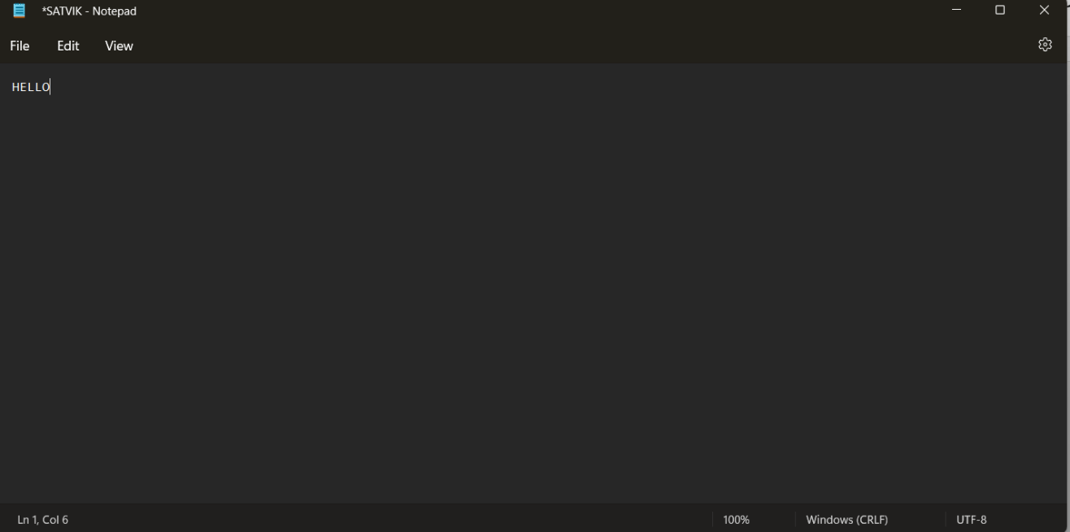

PROGRAM:-58**:-** Write a program to implement gets() and puts() function in file handling

SOURCE CODE:

#include<stdio.h>

int main()

{

char name[30];

printf("Enter name: ");

gets(name); /

printf("Name: ");

puts(name);

return 0;

}

**OUTPUT:**

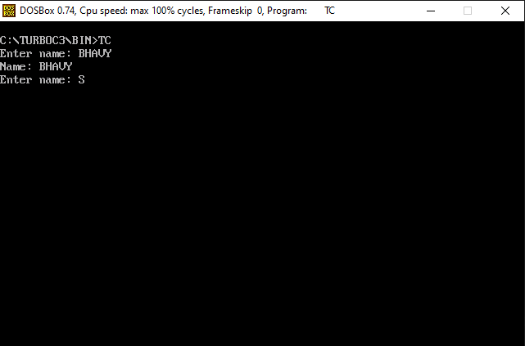

**Program 59:-**Write a program using pointer to compute the sum of all elements Stored in the Array.

Source code:-

#include<stdio.h>

int main(){

    int arr[5];

    int Sum=0,*p,i,j=0;

    printf("Enter 5 element you want to sum ");

    for ( i = 0; i < 5; i++)

    {

        scanf("%d",&arr[i]);

    }

    p=arr;

    while (j<5)

    {

        printf(" \n %d. %d",j,*p);

        Sum = Sum+*p;

        j++;

        p++;

    }

    printf("\n Sum of all elements = %d ",Sum);

    return 0;

}

printf(" \n %d. %d",j,*p);

        Sum = Sum+*p;

        j++;

        p++;

    }

    printf("\n Sum of all elements = %d ",Sum);

    return 0;

}

**Output:**

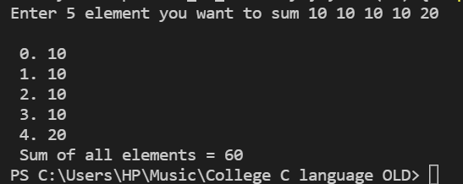

PROGRAM:-60**:-**write A program  to read the Text file containing Some Sentences use fseek function and read the text After Skipping n Character from beginning

of file

SOURCE CODE:

#include<stdio.h>

void main(){

    FILE *fp;

    int n; char ch;

    fp=fopen("Text.txt","w");

    while (ch!='.'){

        ch= getchar();

        putc(ch,fp);

    }

    fclose(fp);

    fp=fopen("Text.txt","r");

    printf("\n content of the file \n");

    while ((ch=fgetc(fp))!=EOF){

        printf("%c",ch);

    }

    fclose(fp);

    fp=fopen("Text.txt","r");

    printf("How many character you want to Skip \n");

    scanf("%d",&n);

    fseek(fp,n,SEEK_SET);

    printf("information after Skip n Character \n");

    while((ch=getc(fp))!=EOF){

        printf("%c",ch);

    }

    fclose(fp);

}

**Output:-**

